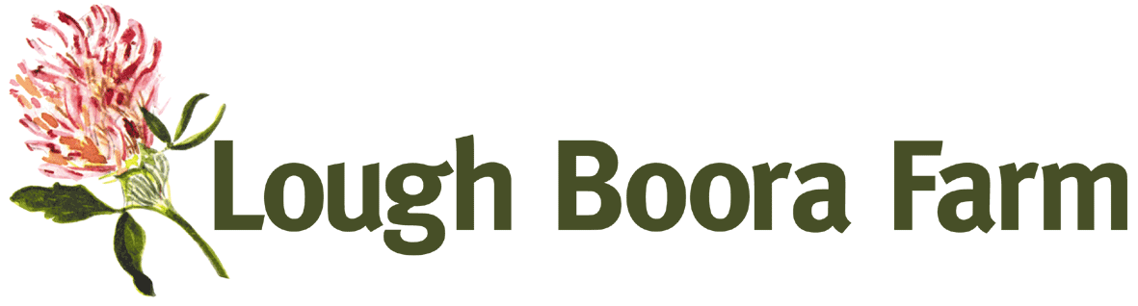
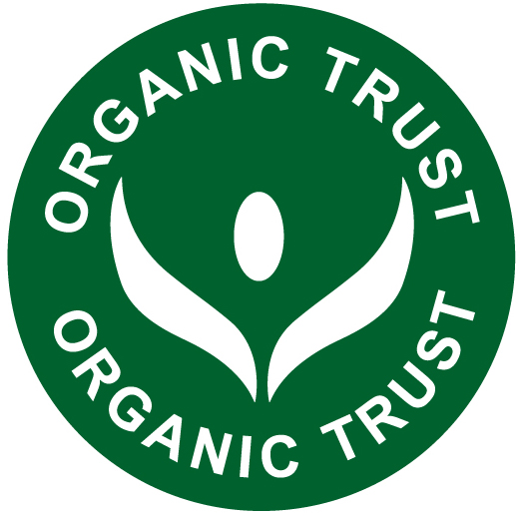
Lough Boora Farm Job Opportunity

The Farm
Lough Boora farm is one of the longest established organic farms in the Irish midlands. Mainly grassland, it produces organic beef and lamb. About 5has of the farm is devoted to organic vegetable production with over fifty different vegetables grown in polytunnels and in the fields. Small amounts of organic fruit are also grown. Lough Boora farm is also licenced to import organic fruit and out of season vegetables, which complements our own large range of home produced, seasonal vegetables.

Most of the produce from Lough Boora farm is sold directly to the end consumer. Our organic meats are sold in bulk for freezer orders and in small quantities at our market stalls or with our weekly vegetable boxes, which are delivered direct to customers throughout the midlands all year round. Sales are currently running about 10% ahead of the same period last year.

The Job - Horticultural Manager
Our horticultural manager of eighteen seasons has decided to leave in pursuit of other interests. We are seeking a replacement for the new growing season.
The role is to plan and oversee the production of the wide range of seasonal vegetables needed for our expanding business.
The ideal candidate will have a proven track record of organic vegetable production on a scale commensurate with ours, S/he will have demonstrated people management skills at a high level. S/he will have the drive and ambition to continually grow the business.

As the current owner nears retirement there is an opportunity for an equity share in the enterprise. Accommodation available locally if needed. Applications with CVs to Lough Boora Farm, Leabeg, Tullamore, Co Offaly by Friday December 15th. For more information contact us directly by phone at 057-9345005 or by email at loughboorafarm@gmail.com loughbloughboorafarm@gmail.com

