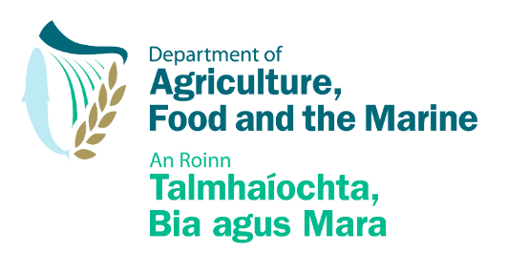
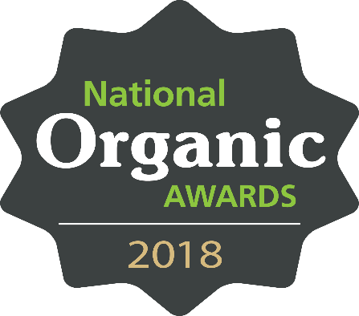
In association with

Introduction
The National Organic Food Awards celebrate the achievements of an increasing number of Irish Organic food and drink growers and manufacturers. Held every 2 years, the awards recognise developments in the sector across key categories as judged by a panel of experts. A new award in 2018 highlights the sustainability achievements and contributions of organic producers to their local communities. Entries will be accepted until Monday 3rd September.
Award winners will be announced at an awards brunch on Wednesday 10th October 2018 in Bord Bia Head office.
www.bordbia.ie/organicawards2018

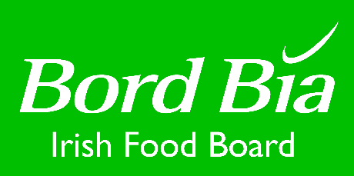
Growing the success of Irish food & horticulture
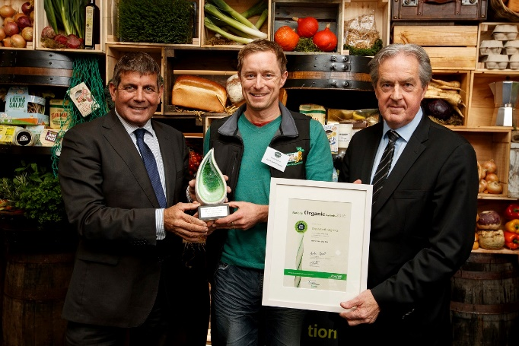
Award Categories 2018

1. Chef’s Award
To include products currently available through Irish foodservice channels (restaurant, hotel, café, institutional catering). Judging criteria will include taste and quality, versatility, market opportunity and value for money.

2. Retail Award
To include products currently available through Irish retail channels. Judging criteria will include taste and quality, market opportunity, value for money, packaging and branding.

3. Direct Selling Award
To include products being sold directly at farm gate, via box schemes, online or at food markets etc. Direct sales should represent a majority of sales turnover (more than 50%). Judging criteria will include, creativity and flair in sales, customer service approach and what direct selling represents to the business.

4. Export Award
To include products for sale in export markets. Judging criteria will include, innovation for the market, evidence of success (sales results), ability of company to overcome export challenges and expected export growth in 2018/2019.

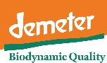
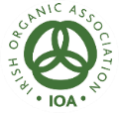
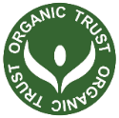
5. Best New and Innovative Product
Open to products launched between January 2017 and August 2018. Judging criteria will include market opportunity, achievements in sales growth to date, innovation and insight used to meet consumer’s changing needs in the development of product, packaging or service.

6. Business in the Community Award – NEW 2018
This new category will reflect the achievements of businesses in their local communities. All entrants should submit details of the corporate and social responsibility initiatives which their company has undertaken.
A shortlist of all producers entering the awards will be judged for their achievements in this area.

Awards

Winners will receive a tailored support package to the value of approximately €12,000 to assist in growing their businesses. They will be assigned a mentor to aid in the tailoring of a suitable supports, elements will include; commercial marketing strategy, developing communication and PR plans, branding supports and assessing market opportunities.

Winners in each category will be presented with an Irish made hand sculpted trophy
and an award certificate. Winners are entitled to use the awards symbol for on-pack promotion. All shortlisted companies in each category as well as subsequent winners will be promoted by Bord Bia in print, broadcast and online media.
Rules of Entry
The objective of the National Organic Awards is to recognise the achievements of Irish manufacturers of organic food and drink. Criteria will therefore be strictly adhered to, as follows:

- Product must be grown or manufactured in the Republic of Ireland. Repackaged product is not acceptable.

- Raw material (e.g. all meat and fish) must be sourced in Ireland where possible.

- Products must be certified as organic by IOFGA, Organic Trust, Global Trust or equivalent and certification must be available on request.

- Retailers and foodservice companies may submit private label products on behalf of the producer. Awards would be shared, but the value of prize would go to producer.

- Judges or their related business cannot enter the awards.

- All products must be available on the market at time of submission for Judging.

- A single product may only be entered in a maximum of 2 categories.

- The awards organisers reserve the right to place entries in whichever category they deem as most appropriate.

- Producers must be available to attend awards ceremony on 10th October. If short listed, they must also be available to attend advance photography sessions in Dublin Week on 20th or 21st September.

Entry Requirements
Completed entry forms must be received by Monday 3rd September 2018.
Only entries on the official entry form will be accepted.

Forms should be submitted to Elisabeth Ryan:
Email: organic@bordbia.ie
Tel: 01 614 3672
Key Dates
3rd September:
Deadline for applications.
11th September:
Deadline for delivery of products
12th September
Judging Day
20th & 21st September
Photography of shortlisted entrants
10th October:
Award Ceremony & Brunch (Bord Bia)

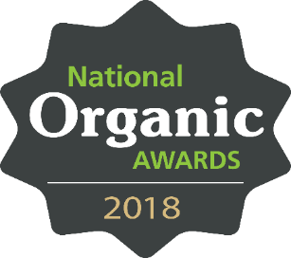
Delivery of Product for Judging
Two sample products per category entered, with packaging, must be
delivered to Bord Bia offices no later than 5pm on Tuesday 11th September.

Dry goods may be delivered from Friday 7th September.
Fresh produce can only be accepted on Monday 10th and Tuesday 11th September.

- All samples must be clearly labelled ‘National Organic Awards’.
- Products must be labelled clearly with storage and cooking instructions to ensure that they are correctly stored and prepared for judging.

The organisers cannot accept any responsibility for lost or undelivered samples.
Failure to supply the samples at the requested time and date will mean that your entry cannot be judged.

Delivery address:
National Organic Awards,
Bord Bia, Clanwilliam Court,
Lower Mount Street, Dublin 2.

Entry Form

Company Details
Company Name | ……………………………………………. |  | Tel | …………………………………………….
Contact Name | ……………………………………………. |  | Mobile | …………………………………………….
Email | ……………………………………………. |  | Website | …………………………………………….
Address | …………………………………………………………………………………………..
Company Turnover | 2016  €….. | 2017  €….. |  |  | 2018 estimated  €…..

Business in the Community  Include details of specific measures you have taken within your company to increase sustainability and contributions to your local community.  You can list CSR measures and policies under any or all of the following headings: Community, Workplace, Marketplace, Environment.  Your submission may be followed up with a call or visit.  (Max 120 words). | Click to enter text. Maximum 120 words

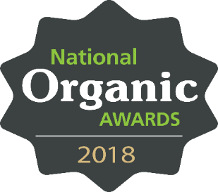

Product Details

Product Name | Category | Source of Primary Ingredients | Shelf Life | Pack Size | Retail Price | Where is product available? i.e. retail outlets, farmers markets, foodservice outlets, export etc.
 | Choose category from the list |  | In days | In g/kg | €
 | Choose category from the list |  | In days | In g/kg | €
 | Choose category from the list |  | In days | In g/kg | €
 | Choose category from the list |  | In days | In g/kg | €
 | Choose category from the list |  | In days | In g/kg | €
 | Choose category from the list |  | In days | In g/kg | €
 | Choose category from the list |  | In days | In g/kg | €
 | Choose category from the list |  | In days | In g/kg | €
 | Choose category from the list |  | In days | In g/kg | €
 | Choose category from the list |  | In days | In g/kg | €
Don’t forget to complete the category specific questions overleaf!
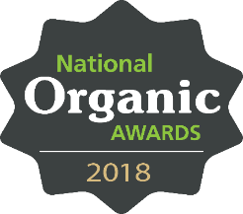
Category Specific Questions
Note that we may also follow up with entrants for additional details
Category 4: Export Award  Please support your application for this category with information regarding your export sales results to date, details of how your business has overcome export challenges and details of anticipated export growth in 2018/19.  (Max 120 words). | Click to enter text. Maximum 120 words
Category 5: New product Award  Please support your application for this category with information regarding consumer and/or market insight in the development of your product, packaging or service innovation. Include the launch date and sales growth achieved since the product launch. (Max 120 words). | Click to enter text. Maximum 120 words
Category 7: Chef’s Choice Award  Please support your application for this category with information regarding your product’s suitability for use in the foodservice context, outlining any particular information regarding its versatility and other benefits in this context. (Max 120 words). | Click to enter text. Maximum 120 words

ALL ENTRY FORMS MUST BE RECEIVED BY MONDAY 3RD SEPTEMBER 2018
Please send by email to: organic@bordbia.ie

