 | Lettuce Fusarium Wilt | Technical Note  Horticultural Unit

Introduction
Fusarium wilt of lettuce has been confirmed in Ireland in 2017 which mirrors a similar outbreak in the UK. The disease was first found on lettuce in 1955 in Japan. The disease was then detected in other Asian countries, in the USA and finally in Europe - initially in Italy (2002) and Portugal, and since confirmed in France, the Netherlands and Belgium. Fusarium is becoming a serious concern to growers in all of those countries.

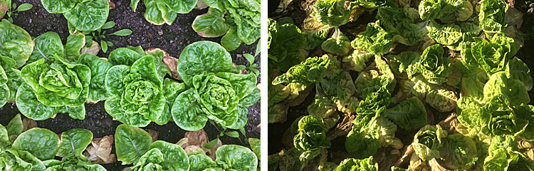
Fusarium wilt on butterhead (right) and baby gem (left)

Causal agent
The cause of Fusarium wilt of lettuce is Fusarium oxysporum f. sp. lactucae – this strain of Fusarium attacks only lettuce/lamb’s lettuce. All lettuce types are susceptible, particularly butterhead and baby gem, but there are degrees of resistance in breeding lines . The fungus forms long lasting resting spores called Chlamydospores. In the absence of a host crop the disease can survive on dead plant material. For these reasons the disease can persist in the soil for several years. There are a number of races of this disease with races 1-4 present on the Continent and race 4 identified in the UK.
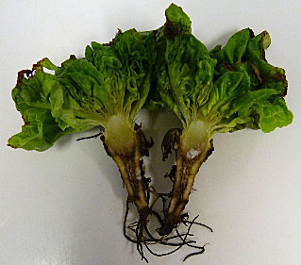
Symptoms
Fusarium invades lettuce plants through small roots, then grows within the xylem tissue, which transports water and nutrients from roots to plant foliage. Initially the crop can look alright but as it develops you may notice the bottom leaves beginning to yellow. As the disease progresses the basal leaves become necrotic and the plant wilts particularly in bright weather. The wilting is caused by the water conducting tissue in the plant becoming blocked by the fungus, which results in restricted water uptake, stunting, wilting, and often plant death. If you cut down through the stem the vascular system is red-brown to dark brown and this discoloration also develops in the centre of the crown and taproot. This disease could be confused with Pythium.

Disease cycle
The disease is soil borne and does not spread by windblown spores. The growth of the fungus is greatly favoured by warm temperatures with the optimum soil temperature being 24-28°C but can be active down to 10°. This implies that it is a disease more of glasshouse crops than outdoor and will be worst in protected summer crops. However the latest strain 4 may be more competitive at lower soil temperatures.

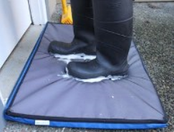
Disease spread
The main way that this disease can spread is via soil contamination of fresh ground. Infected soil can be carried in many different ways: on boots and shoes, tillage equipment and tyres, plant crates, boxes etc. The disease can also be spread via infected seed and water.

Chemical control
- There are no foliar fungicides available. Disease inoculum can be reduced but not eliminated by soil sterilisation.

Cultural control
- This is a persistent and difficult disease so try to avoid getting it if at all possible.
- Inspect crops frequently so that the disease can be identified at an early stage – contact Teagasc to confirm the disease.
- If disease is found bag the infected plants and remove from the holding.
- Cease growing lettuce in the affected house/tunnel and avoid moving contaminated soil to unaffected areas.
- Ask your seed supplier whether the seed has been tested for F. oxysporum and enquire about fungicidal seed treatments.
- Check with your propagator in relation to sterilisation measures taken.
- If carrying out your own propagation ensure that trays and equipment are sterilised to reduce risk of disease carryover between crops.
- Restrict movement of people into the nursery particularly if an outbreak has occurred in your locality. Provide protective clothing for those who do visit.
- Sterilise footwear, equipment, trays, pallets, concrete areas and structures.
- Practice as wide a rotation as possible between lettuce crops.

Stephen Alexander
November 2017

