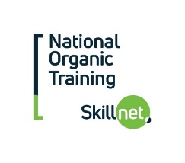

Organic Production principles

Intensive 25-hour Weekend Course
(Friday and Saturday’s)

Location:

The Horse & Jockey Hotel, Horse & Jockey, Co Tipperary

Trainer: Mary Lynch

Course Fee: 220

Funding provided by the National Organic Training Skillnet (NOTS)

Booking Essential- Contact Nots 071 9640688 / EMAIL info@nots.ie
wE CAN NOW TAKE REGISTRATIONS ON OUR WEBSITE AT www.nots.ie

Course fee €220

Course Content:
- Review the origin and history of organic production
- State the principles of organic production
- Interpret the Organic Standards
- How to complete an organic conversion plan
- Assess the economic viability & market opportunities for organic production.
- Preparing a business plan for farmers considering conversion
- Background to organic production
- Principles of organic production
- Organic Standards
- Economics of organic production
- Organic Scheme requirements

Applicants must attend each session. Farm walks and classroom sessions may be changed due to weather conditions.

This course is a QQI / FETAC Certified Course and all applicants must provide to
proof of their PPS Number and copy of birth cert

Course Timetable (Total 25 hours)

- Friday 8th March 2019
Classroom Session 3pm-10pm

- Saturday 9th March 2019
Classroom Session + Afternoon Farm Walk 10am-5pm

- Friday 29th March 2019
Classroom Session 3-10 pm

- Saturday 30th March 2019
Classroom Session & Farm Walk 10am-5 pm

On completion of the course, participants will be proficient in:
- Interpretation of organic standards
- The principles of organic production
- Assessing economic viability and market opportunities

