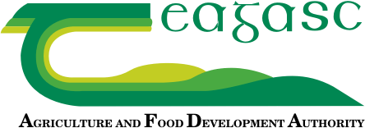
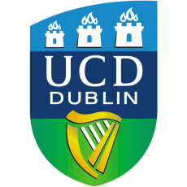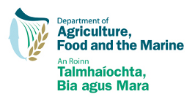
Grass-fed beef:
Marketing opportunities and the scientific evidence
10.00-15.00, 11th December 2018
Teagasc Food Research Centre, Ashtown, Dublin 15

Ireland is well known as a food island, and the positive imagery associated with our grass-based beef production systems gives us many advantages in the market place. However with increasing interest by retailers and consumers in the evidence behind actual and inferred product credentials, the Department of Agriculture, Food and the Marine funded a 5-year research project which examined the scientific basis for any potential nutrition and health claims that could be associated with grass-fed beef. In particular, the project aimed to provide new information on:
- The composition of beef from grass-based production systems for inclusion in food composition databases
- Data on the comparative effects of different types of beef on human health from animal and human studies.

At this one-day workshop the results of the GrassBeef project will be presented and insights from marketing and regulatory perspectives will be provided by external speakers. These results and insights will be discussed, in workshop format, by key stakeholders from research and industry who will attend the event to identify the opportunities that arise as a result of these new data and to outline the next steps that are required to bring such opportunities to reality.
Admission is free; however you are requested to register with eventbrite for organisational purposes:

https://www.eventbrite.com/e/grass-fed-beef-marketing-opportunities-and-the-scientific-evidence-tickets-52813624974

AGENDA
Chair: Prof. Aidan Moloney, GrassBeef project coordinator, Teagasc

9.30 to 10.00 | Registration and networking
10.00- 10.10 | Opening, welcome and overview of GrassBeef | Prof. Aidan Moloney
10.10-10.30 | What the market wants from beef? | Joe Burke, Beef & Livestock Sector Manager, Bord Bia
10.30- 11.00 | Nutritional Composition of Beef as affected by Cattle Diet | Prof. Aidan Moloney and  Prof. Frank Monahan, GrassBeef Principal Investigator, UCD
11.00-11.30 | Dietary Fat Modification in Beef: Implications for Nutrition and Health | Prof. Helen Roche, GrassBeef Principal Investigator, UCD and  Dr Briege McNulty, UCD
11.30-12.00 | COFFEE
12.00-12.30 | Nutrition and Health Claims – Navigating the Current Regulatory Environment’ | Sinead O’Mahony, Technical Executive, Public Health Nutrition, FSAI
12.30-13.20 | Where to next?  Workshop Activities: Led by Prof. Maeve Henchion, REDP, Teagasc
13.20-13.30 | Conclusion – identification of key market opportunities and challenges to capture the benefits of grass-fed beef including next steps |  | Prof. Aidan Moloney
13.30-14.30 | LUNCH

