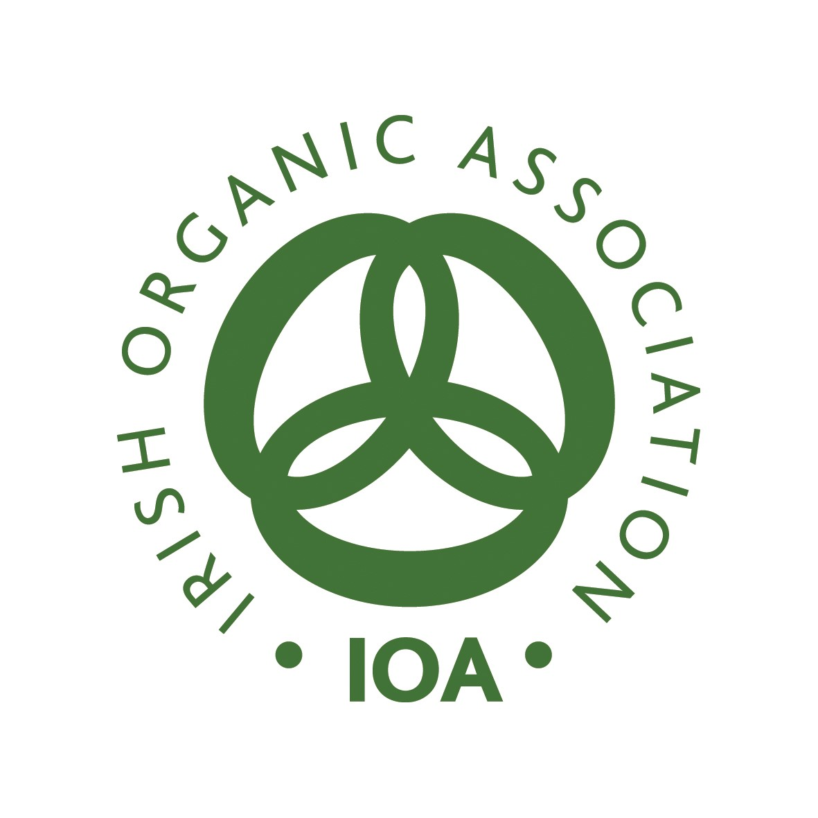 Animal Health Plan template
- The Animal health plan is an active management tool aimed at promoting the health and welfare of farm animals.
- The plan should set out disease prevention, detection and management procedures.
- It should be based on farm specific issues ensuring that illness, injury and mortality amongst farmed animals are at minimum levels providing information on procedures that promote positive health and welfare.
- The farmer must update the Irish Organic Association with an annual Animal Health Plan.

Name: | Address:
Signature | Date
Herd/Flock Number

Veterinary Surgeon/Practice Contact Details
Private Veterinary Practitioner: | Company: | Email Address: | Phone:
Signature |  | Stamp

Species kept on site: Please tick:
Bovine | Ovine | Porcine | Poultry | Equine | Other: Please provide details

Background information on your business

The main activity of this business is:

VETERINARY HEALTH/LIVESTOCK MANAGEMENT PLAN
What husbandry practices are used on your holding to encourage resistance to disease and prevention of infections? |  |  |  |  |  | Yes | No | N/A
 | Rotational grazing
 | Mixed grazing
 | Appropriate housing conditions
 | Other (please specify)
Mutilations and operations on animals  For information only – permission must be sought from DAFM via IOA in advance of carrying out any of these practices |  | Y | N | N/A | Details (include proposed anaesthetic/analgesic product e.g. Adrenacaine)
Castration (sheep/goats only)
Dehorning (cattle only)
Physical Castration (cattle, deer, pigs)
Vaccinations
Leptospirosis
Clostridial
Respiratory
Pre-calving scour
Parasite Control
Fluke
Stomach Worms
Hoose
Lice/ Flystrike/Scabs
Are there known mineral deficiencies on your holding?
Any Other Health Issues

