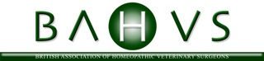

BRITISH ASSOCIATION OF HOMEOPATHIC VETERINARY SURGEONS
WE WOULD LOVE TO WELCOME YOU TO A DAY FARM ANIMAL HOMEOPATHY LECTURES WITH SEPARATE PET LECTURES AT THE BAHVS CONFERENCE ON SATURDAY SEPTEMBER 26th 2015 IN DUBLIN
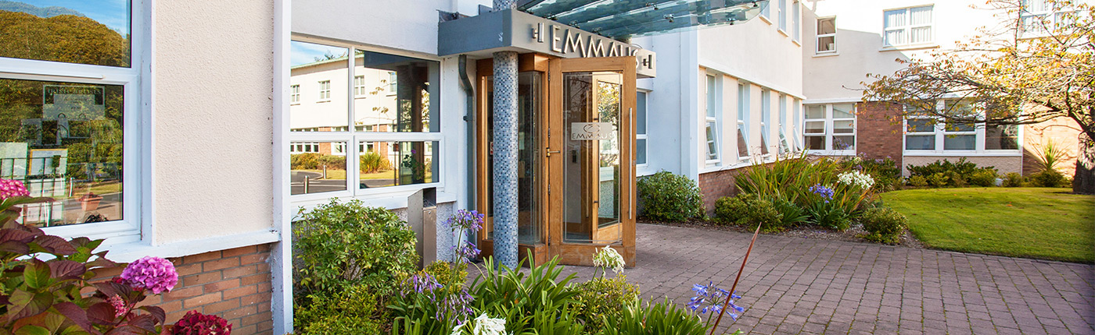
This Years Event promises to one of the best conferences to date with a wonderful line of speakers both home grown and international. The Conference for the first time will be open to human homeopaths and will have lectures on Saturday 26th September 2015 from 9.30am to 5.30pm for the public all in the one location and all promoting homeopathy. Delegates attending the conference will have a choice of attending both the scheduled conference speakers and public lectures. The Public and Farming community can attend separate stream with Companion Animals includin Horses in one stream and Farm Homeopathy in a separate stream but homeopathy is identically applicable in all species
FARM ANIMAL Speakers Tom Farrington & Erica Borge Nicholas
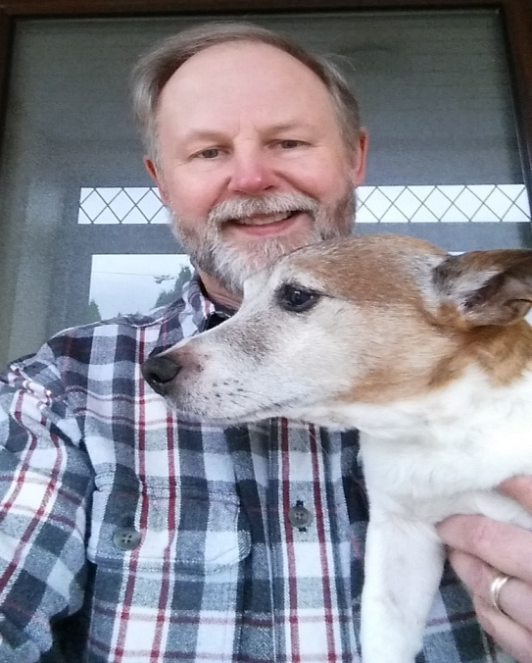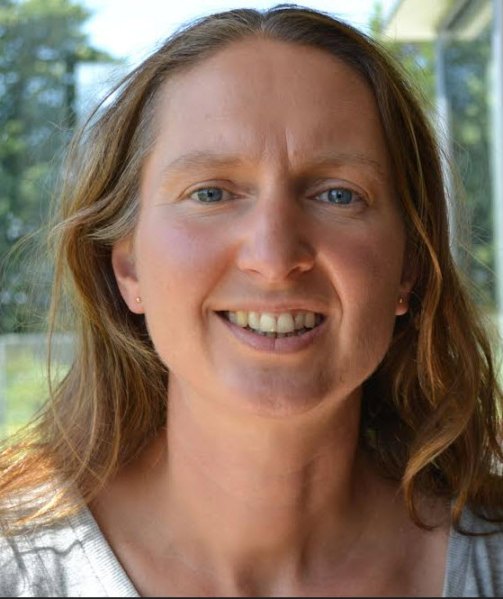
ERICA AND TOM ARE BOTH EXPIERNCED VETERIANRY SURGEONS WITH A WEALTH OF EXPIERENCE IN FARM PRACTICE AND EACH HAS EXTENSIVE KNOWLEGE OF TREATING ANIMALS WITH HOMEOPATHY THEY WILL PROVIDE REALISTIC INFORMATION IN RELATION TO THE EMPLOYMENT OF HOMEOPATHY ON YOUR FARM, BOTH WILL OFFER TIME FOR QUESTION AND ANSWER SESSIONS TO ALLOW EXPLORATION OF OFF SUBJECT TOPICS

HOMEOPATHY ON THE FARM
9:30-12.30
PRACTICAL HOMEOPATHY ON THE FARM
Tom Farrington
2pm-5pm
HOMEOPATHY IN SPECIFIC FARM CONDITIONS
Erica Borge Nicholas

B
BEFORE 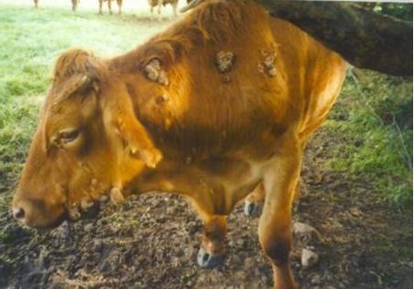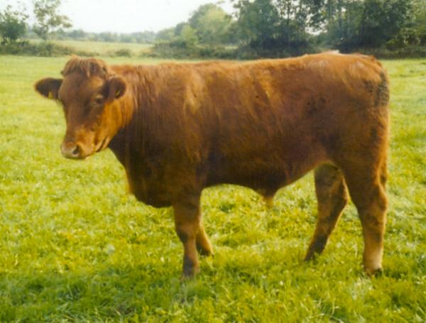 AFTER
The Venue the Emmaus Centre Swords Co, Dublin within 10 minutes of Dublin International Airport by Taxi http://www.emmauscentre.ie/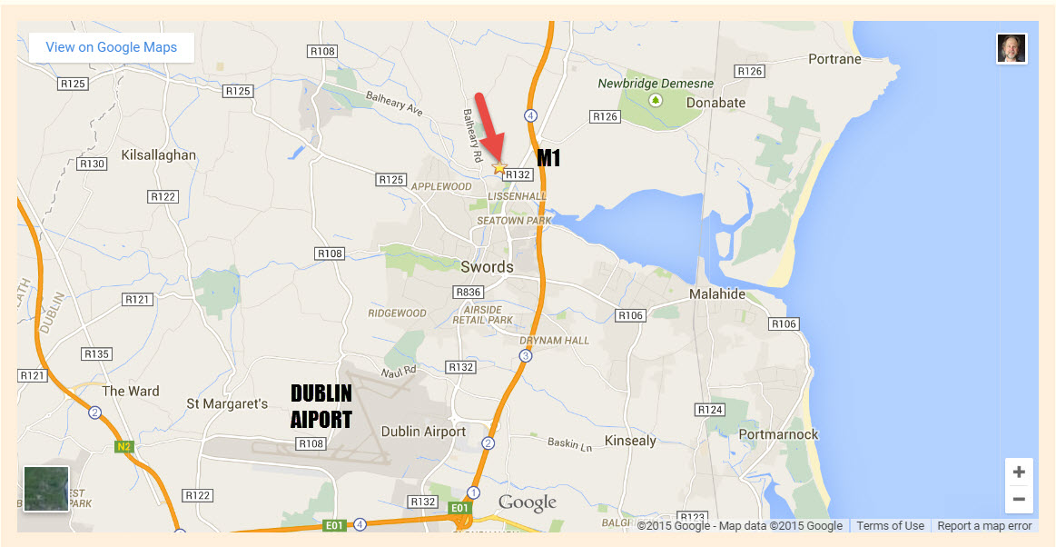

BOOKING PROBLEMS CONTACT TOM FARRINGTON farrington.vet@gmail.com or Erica Borge Nicolas ericathevet@gmail.com
COST FOR THE DAY INCLUDING LIGHT LUNCH AND TEAS AND COFFEES €95.00
IF YOU WISH FULL LUNCH HOUR MEAL COST INCLUDING FULL MEAL IS €105. PLEASE NOTE PLACES WILL BE LIMITED DUE TO PARKING AND OVERALL CONFERENCE NUMBERS CAR SHARING WILL ALLOW MORE PEOPLE TO ATTEND

