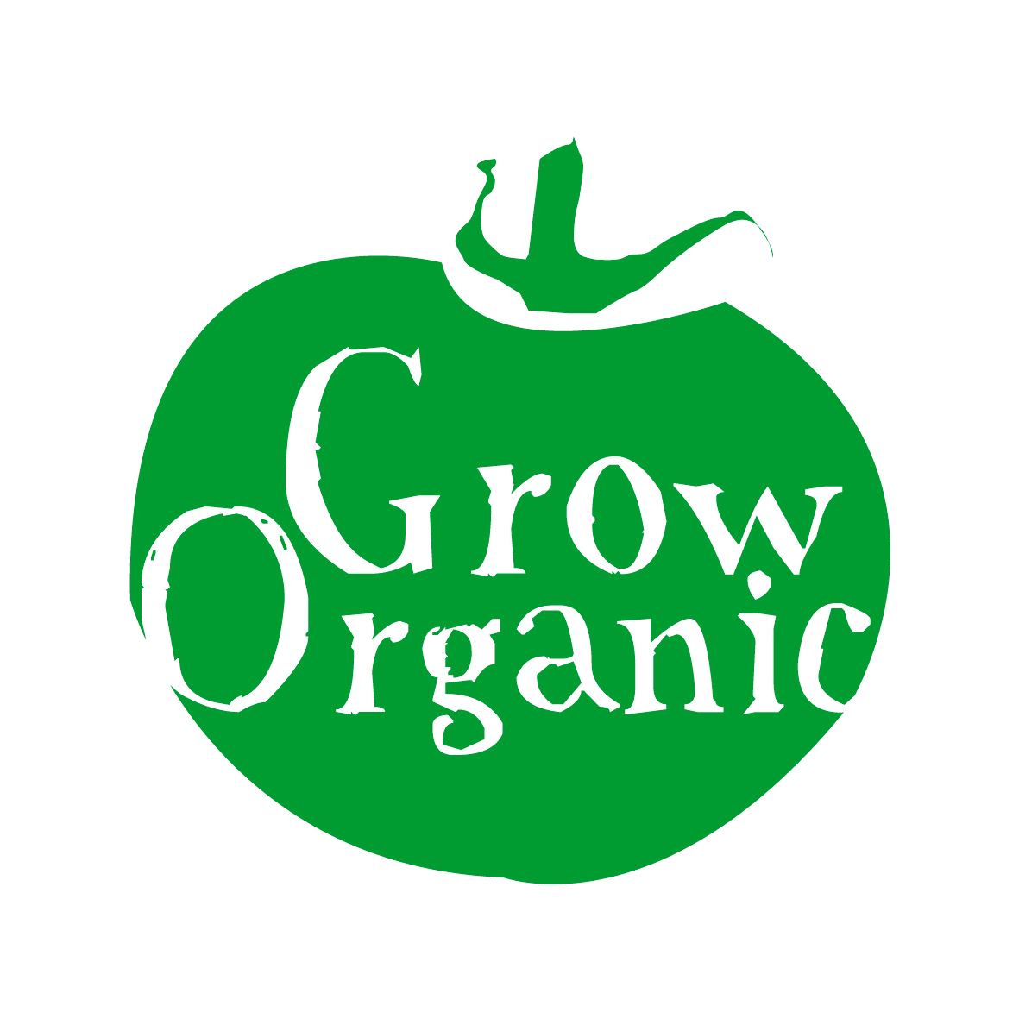
CLASSIFICATION OF VEGETABLE FAMILIES

Vegetables are divided into different families depending on the characteristics that they share. You may be surprised to know what plants are related to one another as they may bear little physical resemblance to each other. A good example is the Solanaceae family which both the potato and tomato belong to. The crops that we eat are not similar to each other but the flower on both of these plants is very similar.

Below you will find a list of common vegetables and the families that they belong to. This is very important for crop rotations in the garden which is practiced by organic gardeners worldwide.

Umbelliferae Family
- Celery
- Parsley
- Carrot
- Celeriac
- Parsnip

Liliaceae Family
- Asparagus
- Chives
- Garlic
- Leek
- Onion
- Shallot

Solanaceae Family
- Potato
- Tomato
- Pepper
- Aubergine

Leguminosae Family
- Pea
- Broad bean
- French bean
- Runner bean

Cruciferae Family
- Brussels sprouts
- Cabbage
- Cauliflower
- Broccoli
- Swede
- Turnip
- Radish
- Rocket
- Khol-rabi

Cucurbitaceae Family
- Pumpkin
- Courgette
- Squash
- Melon
- Marrow

Chenopodociaceae Family
- Spinach
- Beetroot
- Swiss chard

Compositae Family
- Lettuce
- Endive
- Globe artichoke
- Chicory
- Jerusalem artichoke

