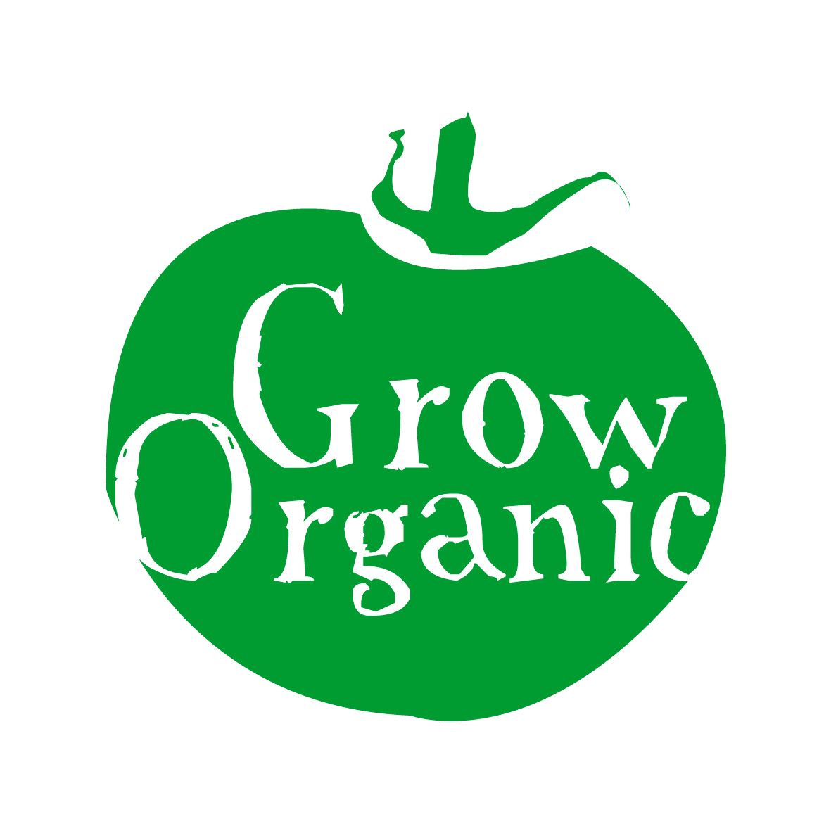

GETTING STARTED…….CLEARING A GARDEN PLOT

In a non organic garden the first step people take in clearing a plot is spraying the plot with a popular herbicide to kill off any unwanted plants and weeds. This is not allowed in the organic garden and the flora and fauna in the plot will thank you for it!

However it is very important that you take the time to totally clear a plot of unwanted plants and especially weeds otherwise they will be a continued menace throughout the growing season.

The following are the most common ways used by the organic gardener to clear a plot;

Mulching:

Mulching is a technique whereby the garden is covered in a material which smothers weeds or unwanted plants in the garden. They are left in the garden for a couple of months in order to ensure that they are effective. The idea is to block out light from the soil to ensure that seeds don’t germinate.
Bio-degradeable mulches include straw, cardboard, newspaper, grass clippings or green waste compost.

You can also use black plastic or mypex which is a thick woven plastic. Neither of these will break down but they are very effective in killing weeds and can be used time and time again in the garden. Black plastic on the ground helps to warm up the soil in spring time as it attracts the sun increasing the temperature under the plastic. Slugs like to gather under black plastic so when you remove the plastic keep a bucket handy to collect the slugs and feed them to birds or chickens if you have any!

Digging:
This will take time and lots of energy! Basically what you want to do is dig up sods of grass using a sharp spade and then turn them over so that the grassy side is facing downwards and the soil upwards. In order to make the job easier you can mulch the ground for a few weeks first this will help kill off the grass and make the soil softer to dig. You can use a spade or a fork for this task and take your time as if it is done well the ground till stay weed free and cleaner for longer!

Rotavating:
You can hire a rotavator from your local garden shop or tool hire centre. If at all possible it is advisable to dig or fork the ground over first before you rotavate it. Rotavating the soil will break up any sods of clay and allow you to cultivate the soil into a fine tilth to make sowing directly into the soil possible. If you can not rotavate the soil don’t worry as a garden plot which is dug over very well will be just as productive!

If you decide to use mulches in the garden then make sure to apply them in large quantities so that they will not blow away. Later on in the season you can plant hardy plants such as courgettes through your mulch. This will help to control weeds during the growing season if you don’t have too much time to keep the garden weed free. If you use bio-degradable mulches they will break down over time and add organic matter to the soil.

