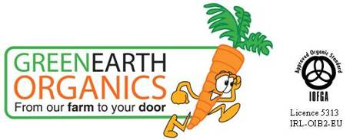

Green Earth Organics was founded in May 2006. It is based on a family farm in Corrandulla 8 miles form Galway city. The business delivers fresh organic fruit and vegetables and other produce to homes all over Galway. We also deliver on a Mayo route as far as Westport.

The farm consists of 28 acres of land. 8 acres are organically certified and the rest is in the second year of conversion. We have a total of nearly 10,000square feet of covered cropping space. We grow a wide range of vegetables all year round, and have plans to plant a mixed orchard of nearly 300 trees this year.

You can order online via our website www.greenearthorganics.ie or sign up for a weekly delivery of one of our seasonal boxes. Everything we sell is certified organic. Generally, in season all the veg comes from the farm. When you join the box scheme you are not just buying veg, you are supporting a local business and doing a major part in reducing your carbon foot print by using locally produced organic food. The box scheme is the best way to access what is in season without having to think too much about it. You will also receive a regular newsletter and recipes about new and unusual vegetables that are going into your box.

Our service is completely flexible and you can adapt or change orders or boxes to suit your needs.

Even though the winter has been harsh and we lost a lot of our spring crops we still have plenty coming out of the tunnels from our fresh mixed salad to radish to scallions and outside the first Rhubarb is just raising its head above its straw parapet!

Currently we are just in the middle of the new growing season and the farm is getting really busy as we gear up for the summer ahead. When there will be lashing of lovely fresh tomatoes, salad and fresh carrots as well as our first early potatoes, and a host of other vegetables that we grow.

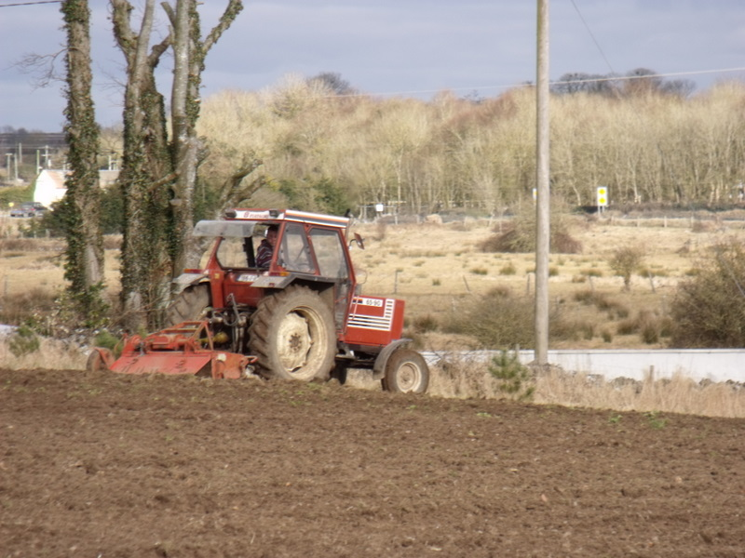
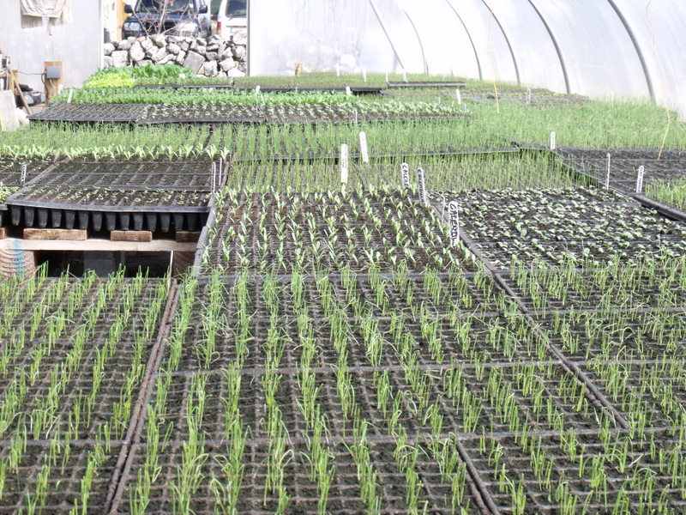
Inside the propagation tunnel out rotovating

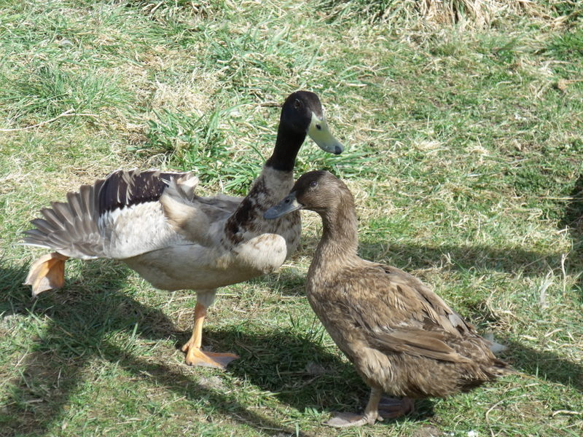
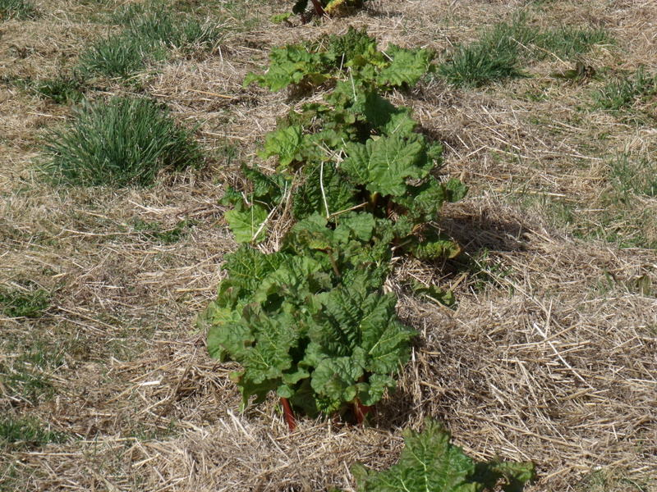
first rhubarb the ducks dancing!
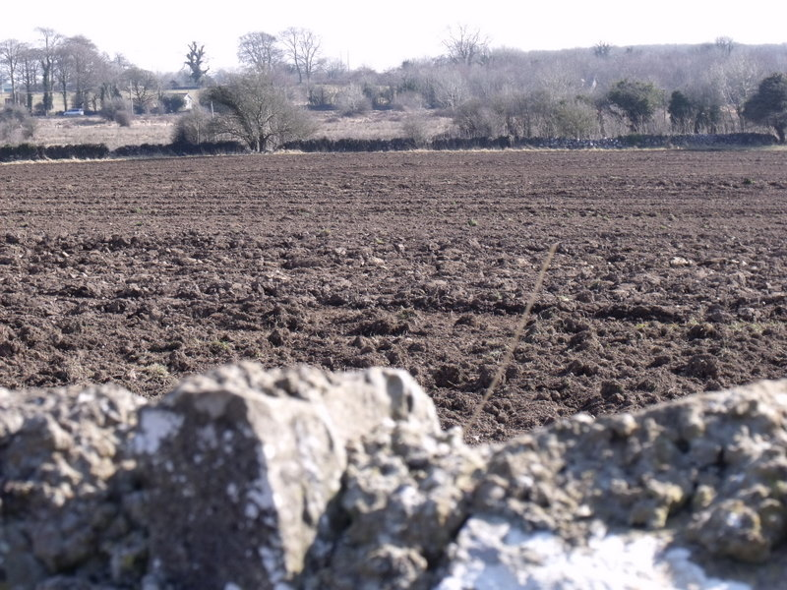
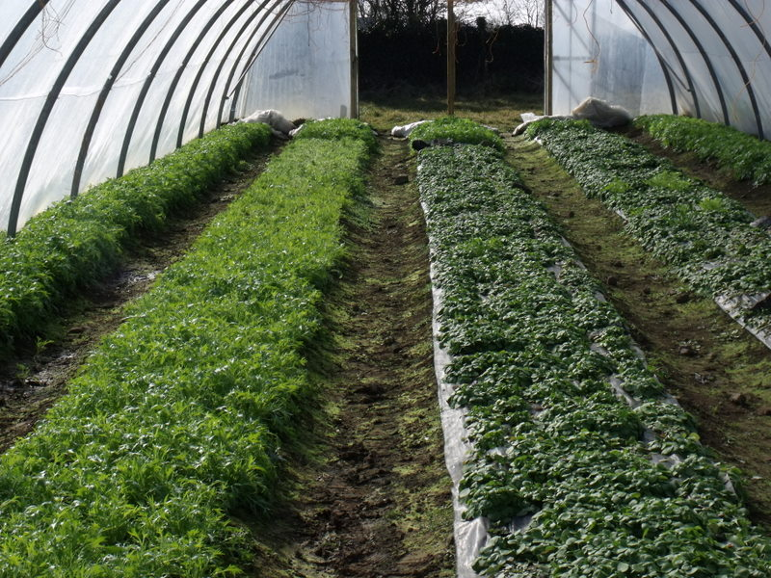
Salad in the tunnels freshly ploughed land
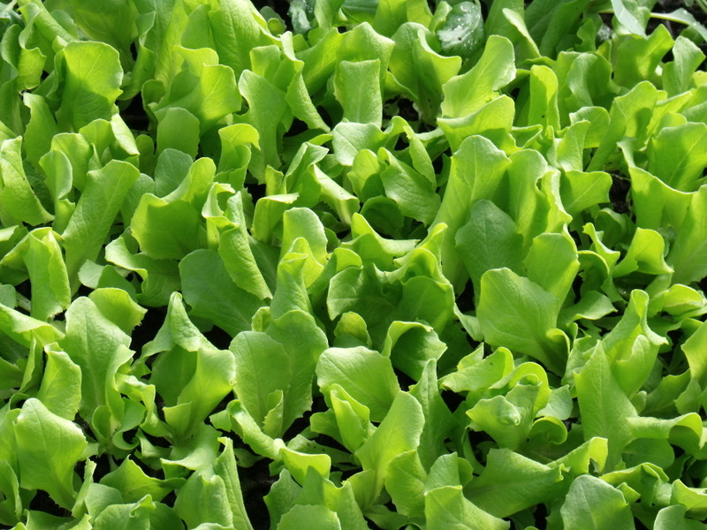
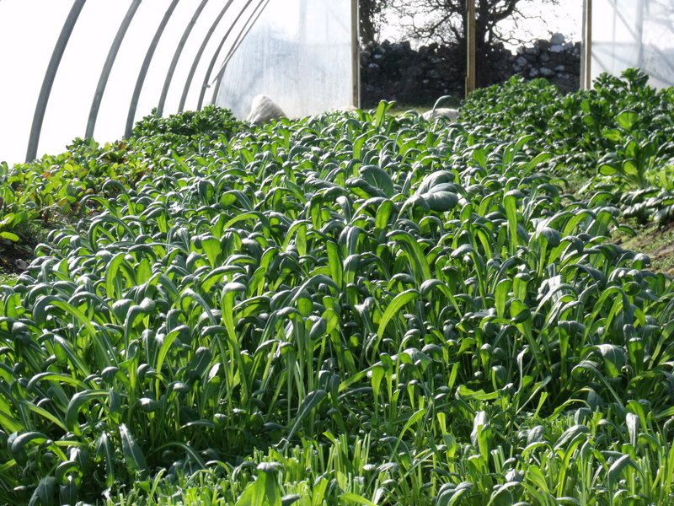
the first lettuce some mibuna for our mixed salad

