Lamb Filo Pie
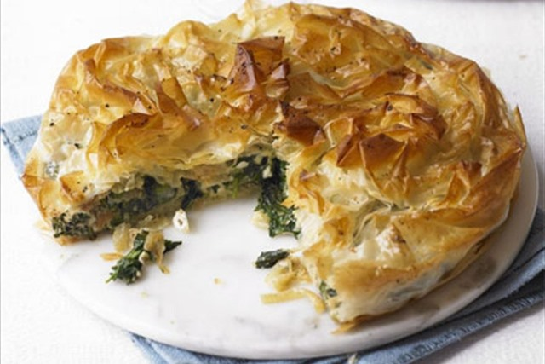
Serves 4
Organic ingredients:
Sunflower oil, for brushing
450g minced lamb
1 onion, sliced
1 garlic clove, crushed
400g can plum tomatoes
2 tbsp chopped fresh mint
1 tsp grated nutmeg
350g young spinach leaves
1 packet filo pastry
1 tsp sesame seeds
Salt and freshly ground pepper
Salad or vegetables to serve
Method:
- Preheat oven to 200C/400F/Gas 6. Oil a 22cm/8.5inch round springform tin
- Fry the mince and onion without fat in a pan until golden.
- Add the garlic, tomatoes, mint, nutmeg and some seasoning. Bring to the boil while stirring. Simmer, stirring occasionally until most of the liquid has evaporated.
- Wash the spinach and remove any tough stalks. Cook in the water clinging to the leaves until lightly wilted.
- Lightly brush each sheet of filo pastry with oil and lay in overlapping layers in the springform tin. Leave enough over-hang to wrap over the top.
- Spoon in the meat and spinach. Wrap the over-hanging pastry over the top to enclose and scrunch it slightly. Sprinkle with sesame seeds.
- Bake for 25-39 minutes or until golden and crisp. Serve hot.

Alternatives you can use chicken or fish instead.

