New Organic Farming Scheme Payment Rates

 | Livestock |  | Tillage |  |  | Horticulture
 | ≥ 3-60ha | >60 ha | < 20ha | >20ha-60ha | >60ha | ≥ 1ha-6ha | >6ha-60ha | >60ha
Conversion | €220/ha | €60/ha | €260/ha | €220/ha | €60/ha | €300/ha | €220/ha | €60/ha
Maintenance | €170/ha | €30/ha | €170/ha | €170/ha | €30/ha | €200/ha | €170/ha | €30/ha

*The higher horticultural rates will apply to the first 6ha only and thereafter the standard rates apply up to 60ha and a reduced rate in excess of 60ha.
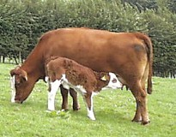
**The higher tillage rates will apply to the first 20ha only and thereafter the standard rates apply up to 60ha and a reduced rate in excess of 60ha. An additional €30/ha is available for red clover up to a maximum of 10 ha per annum.

