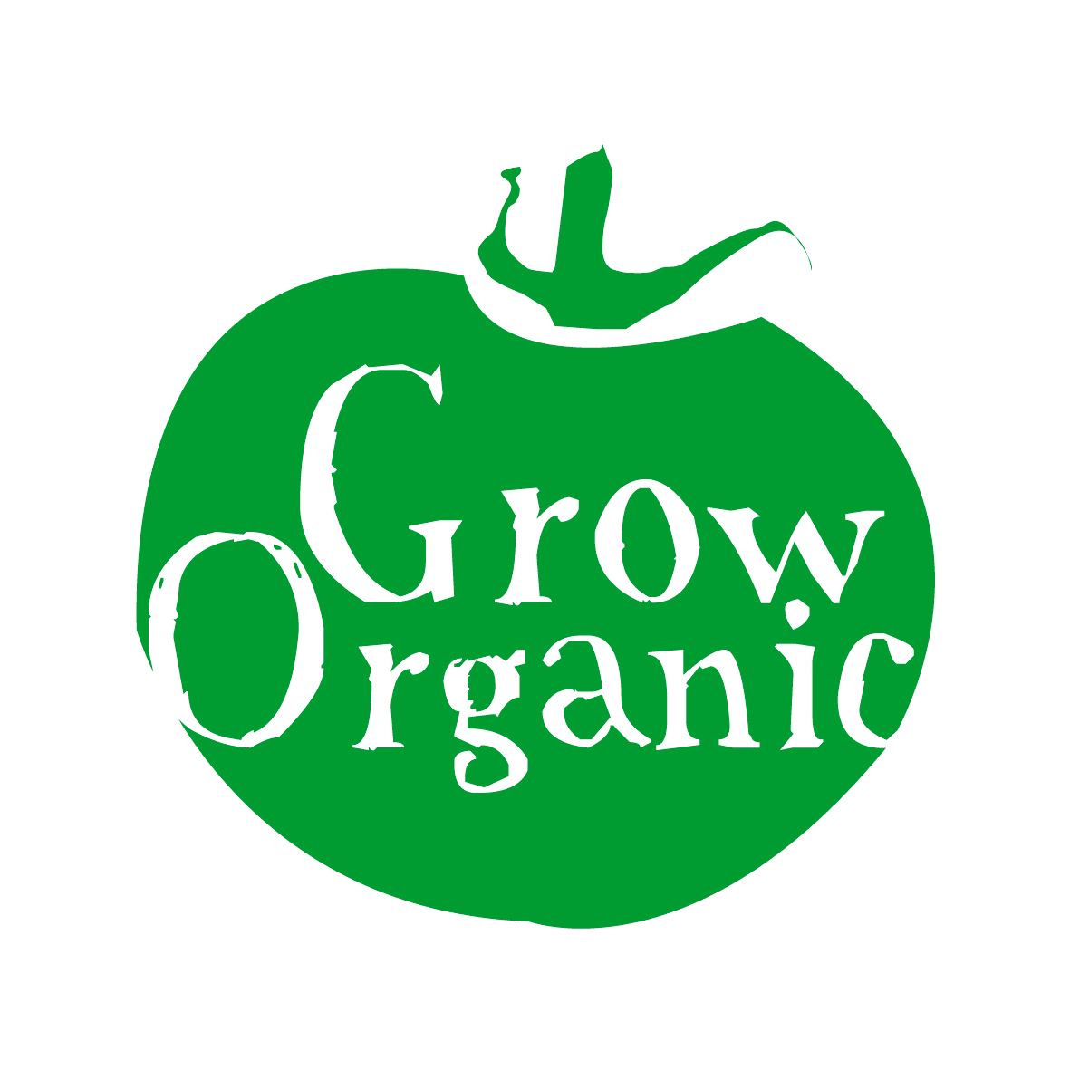

ORGANIC FERTILISERS AND SOIL AMMENDMENTS

Farm Yard Manure: This should be well rotted before being applied to the soil. Fresh manure can scorch plants and may lead to nitrogen being lost as the bacteria in the soil start to break it down. Fresh manure may also contain pest and weed seeds. It is advisable to compost the manure for at least 6 months before use. Farm yard manure (FYM) contains nitrogen, phosphorus, potassium and also some trace elements.

Chicken Manure: This is very concentrated so needs to be added in small amounts. Sometimes it is better to add it to your compost heap where it can be used to activate or kick start the compost heap. It is high in nitrogen and it also contains phosphorus, potassium and trace elements.

Spent Mushroom Compost: This is the waste product from mushroom growing. It is usually made from farm or stable manure. As it is sterilised before use it is free of disease and weed seeds. It has a high chalk (lime) content so can be used to raise the ph of the soil.

Seaweed/ Seaweed dust/ Liquid Seaweed feed:
All seaweed products are high in trace elements and are useful as a top dressing (applying to the top of the soil). They also contain compounds that stimulate plant growth. A general application rate of 4-6oz per sq. yard for seaweed dust is the general rule. Liquid seaweed fertilisers are usually concentrated which need to be diluted before use. General directions are given on the packet for this.

Liquid Comfrey concentrate: This is a liquid feed that is made from the leaves of the comfrey plant. It has high levels of potassium and is beneficial to the fruiting and flowering of plants. It also has low levels of nitrogen and phosphorus. This also needs to be diluted before use.

Nettle Manure: also known as nettle tea, it is a general all purpose plant feed. It is best made with young nettles cut in spring before the nettles go to seed.

Rock Phosphate: This is ground mineral rock. It can be added to the soil when phosphorus levels are low.

Wood Ash: Wood ash contains potash. It is very soluble so needs to be worked into compost heap when fresh or spread directly on soil before planting.

Garden Compost: This is made from broken down garden plant matter and is an important addition to any organic garden.

Worm Compost: is made from kitchen and garden waste using compost worms (brandling or tiger worms). The compost is very fertile, being rich in humus and readily available plant nutrients.

Leaf Mould: is essentially just composted leaves however they take a long time to break down. It is an excellent addition to potting or seeding compost. Leaf mould can also be applied as a mulch. Leaf mould needs to be composted for at least 1 year. The longer you let is decompose the better the structure will be for adding to the soil.

Nitrogen, Phosphorus and Potassium are the 3 main nutrients that plants need to grow. They also need a small amount of trace elements such are calcium, magnesium and boron to name a few.
The continuous supply of organic matter will help light sandy soils to hold on to food and water and heavy clay soils to drain more effectively. By building up the humus content of your soil (decayed plant matter) more nutrients will be available for healthy plant growth and also earthworm activity will be increased.

