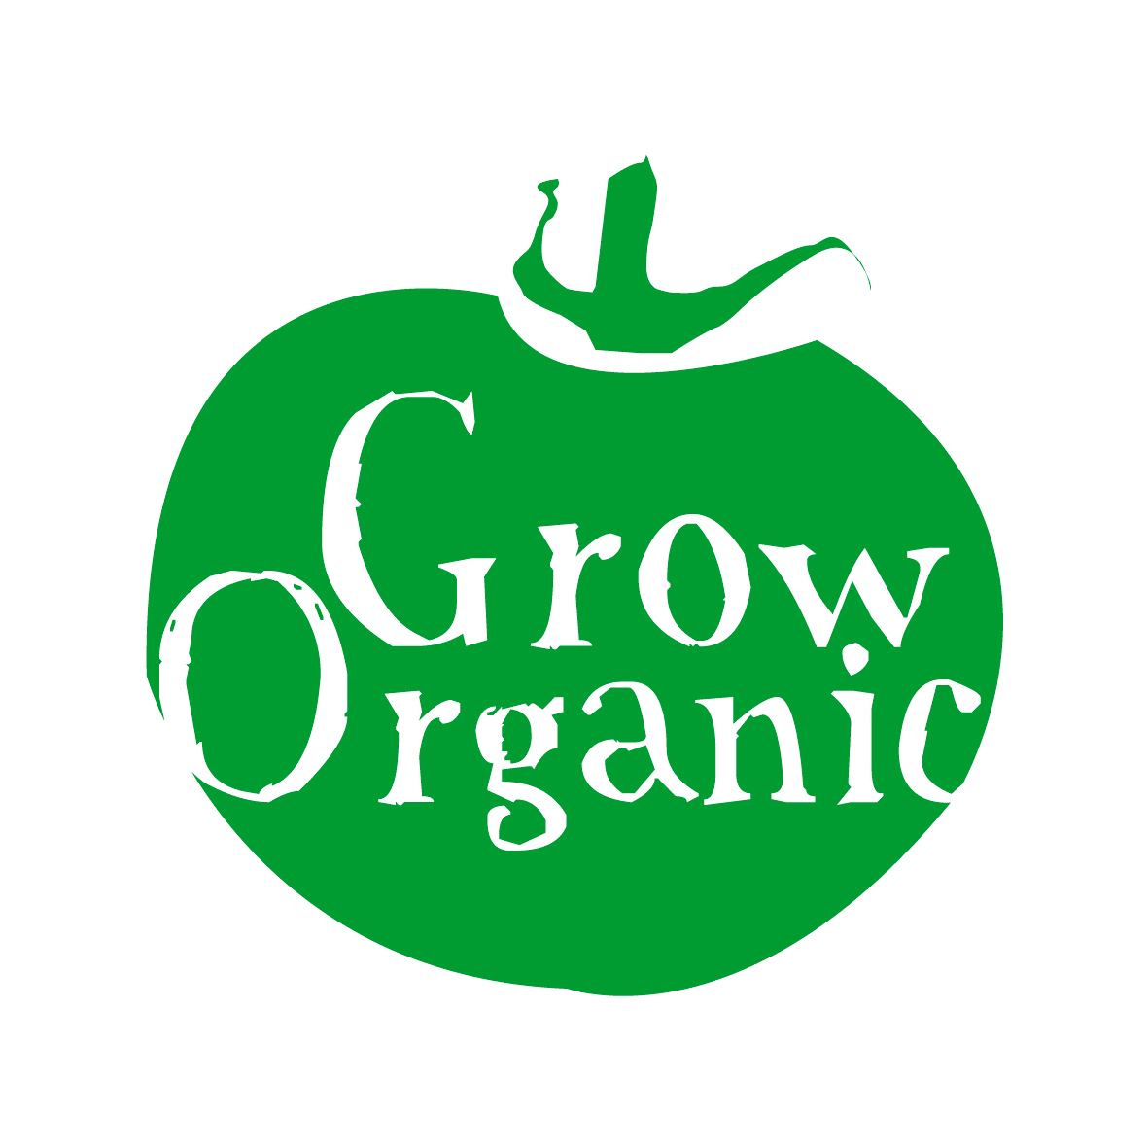
ORGANIC BROCCOLI

Brassica oleracea Family Cruciferae

Broccoli is not an easy crop to grow and quite often what happens is that it is all ready at the same time. It also takes a long time to grow and occupies quite a lot of space so if you are limited on space be aware of this.

One of the good things about broccoli is that if you harvest it on a regular basis then it will crop for a relatively long time so if you like broccoli then it is a good crop to choose. It is part of the Cruciferae or Brassica family so make sure to follow that section of the rotation.

There is some confusion about the difference between broccoli and calabrese however they are essentially the same thing. Sprouting broccoli is the winter variety and calabrese is the summer variety.

Sowing
Broccoli like all of the brassicas such as cabbage, cauliflour etc require a lot of nitrogen in the soil so it is important to add farmyard manure to the soil before planting. If possible add it to the soil the previous autumn so that the nitrogen is readily available to the plant once it goes into the ground.

Sow broccoli seeds in March in a protected structure such as a polytunnel or a coldframe (Download our factsheet on Sowing Seeds for more information). Germination rates are quite good with brassicas. Water the seed trays or modules every day. Once the seedlings have 4 true leaves on them (approximately 4 -6 weeks) leave them out to harden off for a few days. Then the seedlings are ready to transplant into the soil. Transplant the seedlings which have firm stems then protect the seedlings with netting from the birds if the area is not too large.

You will need to have approximately 60cm or 2ft between plants as they grow quite large. Firm the soil in around the base of each plant to stabilise it.

Sprouting broccoli should be sown mid summer and then planted out in summer and then left to grow throughout the winter. The purple sprouting kind can grow as tall as 3ft so make sure to leave about 2ft between each plant when you are transplanting them into the ground.

Care
In the early stages it is important to keep the plants well watered but once they get large enough it should be fine to leave them to depend on rainfall. However if there is a very dry spell then it is important to water them. In the early stages you can also mulch around the base of the plant to keep weeds down and hoe in between plants once they are well established they will keep the weeds down themselves.

If you are sowing sprouting broccoli then you can sow a green manure in around the plants in the ground to keep weeds down it will also add fertility to the soil for you. Make sure that you leave enough space for the broccoli plants. You can then cut down the green manure and leave it as a mulch around the plants for the winter.

Pests
- Birds can be a real pest when the plants are small and have just been transplanted so use netting to avoid birds pulling the plants from the ground
- Caterpillars from the eggs laid by cabbage white butterflies and moths can be a real problem for all brassicas. The eggs are laid on the underside of the leaves so watch out for them. The caterpillars munch their way through the leaves causing damage to the plant. Remove the eggs and also the caterpillars by hand
- Cabbage root fly also like broccoli, the adult flies usually emerge at the same time as cow parsley so be vigilant from then on. They lay their eggs at the root of the plant and then the grubs that emerge burrow into the soil and eat the roots of the plant causing them to collapse. Dig up infected plants and burn them.
- Flea beetle is a small beetle which hops from plant to plant. It attacks when the weather is dry so keep the plants well watered to avoid it
- Slugs and snails love all brassicas particularly if it is a wet summer so keep an eye and remove them if you see them on or near plants

Generally it is a good idea to keep all brassica plants covered with fine netting as it keeps out the majority of pests which are airborne and prevents problems this is particularly important in the summer months. With sprouting broccoli you also have to be vigilant for caterpillars as they will be present on plants in summer.

Diseases
- Clubroot is the main problem associated with broccoli. This is a soil-borne disease which results in swelling on the roots. Once plants have this they generally collapse and die. Dig up infected plants and also non infected plants and burn them do not compost them. It is difficult to get rid of clubroot once you have it as spores may last for up to 20 years in the soil. The only way to ensure that you do not exacerbate the problem is to ensure that you practice a strict rotation and do not put any broccoli or other brassicas in that spot for at least 8 years. It is prevalent in very acidic soils so if you improve the drainage and also add lime to the soil you will reduce the possibilities of getting clubroot.

Harvest and Storage
The key with broccoli is to ensure that you harvest as soon as the spears (the edible bit) are a reasonable size as this will encourage the plants to continue to produce spears for a lot longer. Once the plant has gone to flower then it will stop producing new spears thus your broccoli season is over.

Broccoli does not store well so you can use different varieties to try to increase the growing season. There are also early and late sprouting varieties which can be harvested from January to April which is a real treat as this is a very lean time in the garden and it is great to get fresh greens at this stage in the year. Sprouting varieties produce lots of spears which are much smaller than calabrese so make sure to harvest them on a very regular basis to encourage the plants to continue to produce spears.

When the season is over and the plants are no longer producing you can dig up your plants and if possible shred the stalks before adding them to your compost heap as they will break down much quicker this way.

