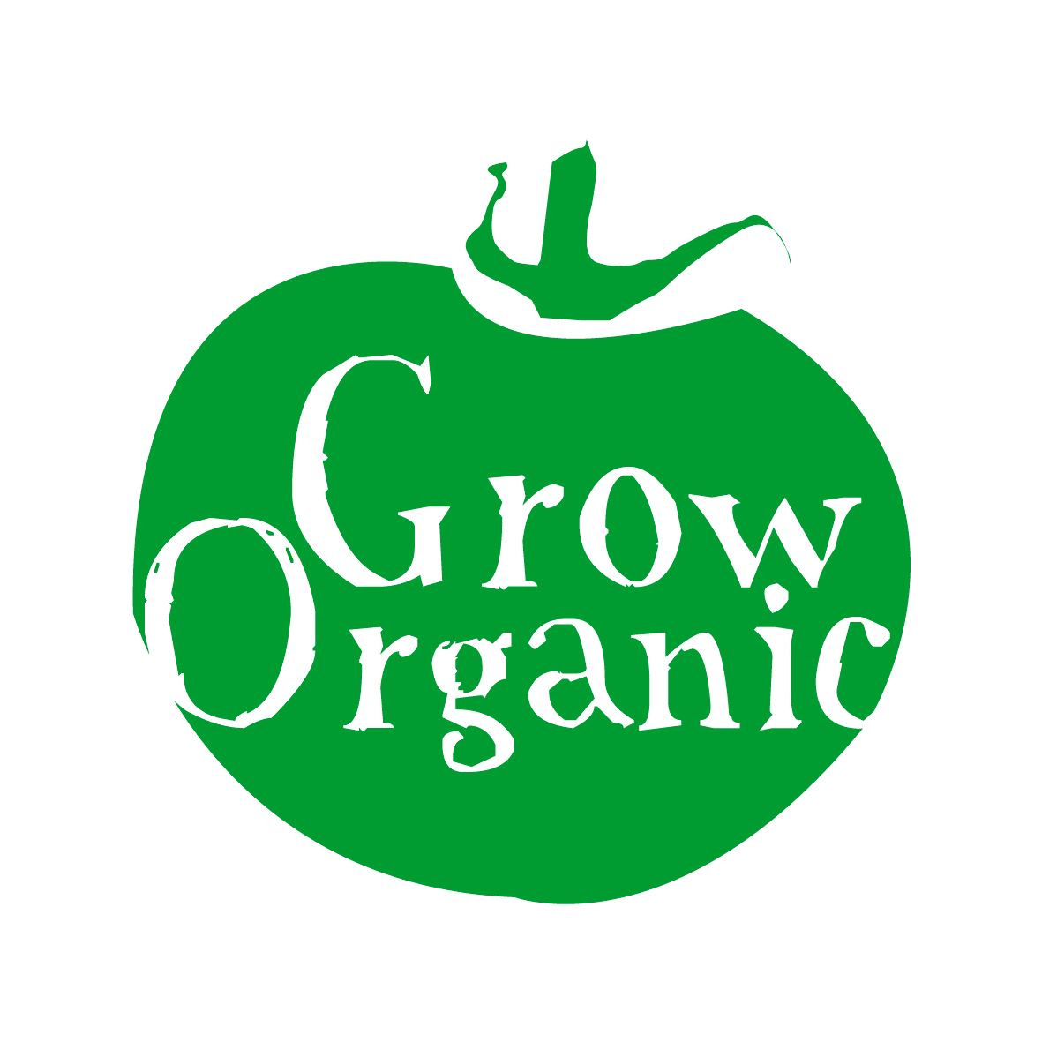
ORGANIC GARLIC

Allium sativum Family Liliaceae

Garlic is one of the easiest vegetables to grow however it is tricky to get the cloves to plump up which is the ones which are the easiest to use when cooking! There are lots of varieties available on the market however it is best to grow one that is suited to this region as many are from Egypt or China and will not grow well in this climate.

Garlic likes a long growing season so start it off as early as possible to ensure that you get a good crop. Garlic is in the same family as onions so keep them in the same rotation area.

Sowing
Garlic like most of the other alliums does not need a huge amount of fertility in the soil to grow well however it is always a good idea to add in some home made compost to the soil to improve soil structure and retain moisture throughout the growing season.

It is not necessary to finely rake the soil as you are planting garlic cloves and not delicate seeds. One garlic clove will expand to produce the garlic bulb that you buy in the shop.

If your soil is prepared then you can plant your garlic in the autumn time. If the soil is not ready then it is a good idea to plant it in late winter or early spring. Garlic which is planted much later than that does not get the time to bulk up and you have tiny little bulbs of garlic which are a nuisance to use in the kitchen!

When planting garlic cloves place the clove in the soil so that the top of the clove is just sitting below the soil surface then cover with an inch of soil. Plant the flat end downwards. You need to give them enough space to bulk out so plant cloves about 20cms apart or at least a hand-space apart.

Care
In the early stages it is important to keep the garlic bed weed free. It is also important to keep it moist not constantly wet but moist. You can water well and add a mulch or else just make sure to water the garlic at regular intervals throughout the growing season. This is important to get good plump garlic bulbs.

Diseases
- Garlic like all of the alliums can be prone to getting rust keeping the plants well watered will prevent this becoming too much of a problem
- White rot is a problem encountered by the alliums this shows as a mouldy white growth at the base of onions. Small black sclerotia or black pustules will develop in this mould and drop into the soil where they can last more than seven years. If you find affected plants be sure to burn them and then rotate the garlic and alliums for 8 years before they return to that spot in the garden.

Garlic is not really prone to any pests in the garden actually garlic sprays are used as a deterrent or repellent for many garden pests.

Harvest and Storage
Garlic unlike their cousins the onions should be lifted when the leaves start to turn yellow which is generally mid to late summer.
When digging up garlic use a fork to ensure that you do not damage the bulbs as this will affect them in storage. Then it is best to dry out the garlic for around 10days before you store it. If the weather is dry then this can be done by leaving it to rest in the sun (download our Factsheet on Organic Onions for more information). If the weather is wet put them in a polytunnel or shed to dry out.

Garlic stores very well and once it has been dried out you can take the garlic and tie the stem around some string and hang it in a dry cool shed over the winter. Alternatively you can use the leaves to plait the garlic and hang it in a shed or pantry. Use the garlic as required over the winter. Once the bulbs turn soft and start to sprout then you will need to use them quickly before they turn mouldy.

You can try to save some seed by planting garlic cloves that you grew the previous year and in this way build up a good supply of home garlic. It is one of the easiest ways to save seed and it can be very successful.

