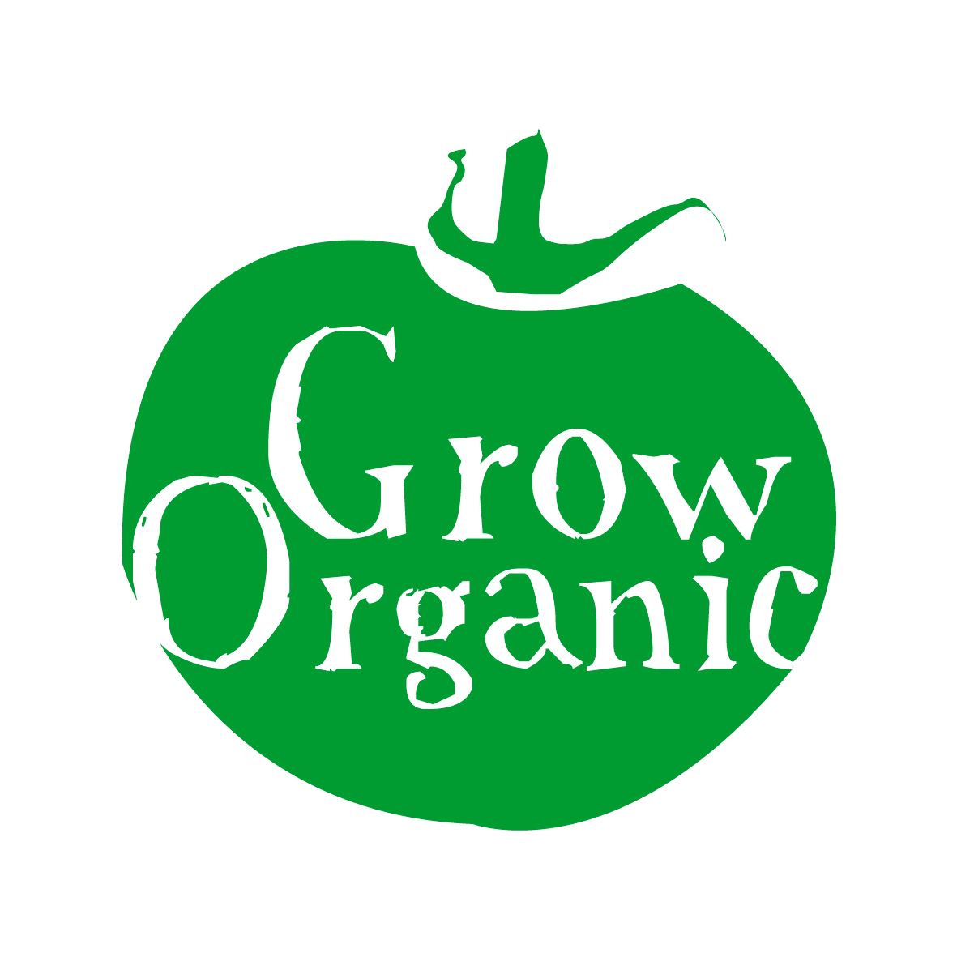
ORGANIC ONIONS

Allium cepa Family Liliaceae

Onions are a pretty easy crop to grow and with some careful planning you can have onions for most of the year. Onions also store very well so if you have the space grow some for storage.
Onions are either grown from seed or from tiny bulbs called sets. If you are new to growing your own vegetables I would recommend that you grow from sets as it is easier and also quicker.

Seeds:
- Less likely to bolt than sets
- Seeds are cheaper than sets
- More labour intensive
- Longer growing season
- Germination rates can be variable

Sets:
- Easier to grow
- Less prone to disease especially onion fly
- More likely to give a reasonable crop in poor soil
- Head start on onion seeds
- More expensive
- More likely to bolt
- Less varieties available

For many small gardeners they choose to grow white and red onions both are grown in the same way. Onions like a soil that has been fertilised (manure added) the previous autumn. They also like a pH of about 6.5 which is the normal range for most vegetables.

Sowing
If you are sowing onion seeds then prepare and sow in the usual way (download our Factsheet on Sowing Seeds). Some people sow onion seeds in multiples so they put about six seeds in each module and then transplant them in a bunch and sow then in situ in a bunch so that all the onions grow together in a clump.
If you are sowing sets then prepare the ground in the usual way and simply place the sets root side down so that the thin neck of the set is just visible above the ground. If you sow sets the wrong way around they will turn themselves around as the root gravitates towards the nutrients in the soil however it requires some energy for the set to do this so it is better to avoid it by sowing it the correct way round. It is better to sow sets in early to mid spring.

If you want to grow a large area of onions some people sow sets through black plastic you simply tuck the edges of the plastic into the soil to secure it then cut a slit in the plastic about 1inch long, enough to allow the neck of the onion to come through. This is left in place throughout the growing season and then removed when you harvest the onions in late summer. You can reuse the plastic each year if you carefully fold it up and place in a shed. The advantage of using black plastic is that it cuts down on weeding and this can be labour intensive if you are growing a large amount of onions.

Planting
If possible add some manure to the soil in the previous autumn. When planting seeds or sets, plant them approximately 5-6inches apart to get good medium sized onions. This leaves enough room for weeding or hoeing around each onion as it grow and matures. Red onions are more inclined to bolt so it is best if they are not planted until the end of April which will reduce the chances of bolting. Watch when planting sets as birds like to pull them out so if you have netting you can place it over the onions for the first couple of weeks.

Care
Onions in general do not require very much care however in the first couple of months you need to ensure that they are kept weed free as they do not compete well with weeds and if they struggle at this stage then it is very difficult for them to catch up and produce a good crop. Once the onions have become well established then to minimise time and weeding you can mulch around the onions with straw or grass cuttings. If we get a very dry spell in the summer then you should water the onions well however generally speaking they will do fine in the Irish climate and you will need to water them only occasionally. If you have used onions seeds you may need to thin them out as the plants mature to make sure that they have enough room to grow.

Pests
- Onion fly is one of the main problems encountered. The female lays her eggs alongside the young plants and the larvae hatch in the soil before burrowing into the base of the bulb. The foliage turns prematurely yellow and wilts and the little white maggots are found down below. To get rid of it remove the affected plants and a handful of soil around the base to ensure that you have removed the maggots. The female onions fly is attracted by the smell of the onions which is strong when the onions are being thinned. Sets do not require thinning so therefore rarely get attacks from the onions fly
- Onion eelworm is uncommon enough. The eelworms are tiny and they get inside the bulbs and distort its shape. It is a soil born problem and a good rotation of 4 years will ensure that you get rid of the problem
- Birds can sometimes pick out onion sets when they are young this can be a problem if the sets are not planted deep enough in the soil

Diseases
- White rot appears as a mouldy white growth at the base of the onions and the foliage will be yellow and wilting. Again as with onion fly remove and destroy the plants at the first signs. A good rotation is important to get rid of this disease however it is quite rare in the first place
- Onion downy mildew is a feature of very wet weather and was common in the last couple of years in Ireland. The stem starts to rot and then spreads to the bulb and the onion is destroyed. Chop off the affected stem and let the bulb dry out before use.

Harvesting and Storage
Onions are ready to harvest approximately 3 months after planting (onions seeds will be longer). When they are ready some of the stems will start to fall over you can then speed things up by breaking all of the stems this ensures that the plant puts its energy into the bulbs rather than the stem. To harvest you simply pull the onion out of the ground. To store the onions you need to ensure that they dry out fully otherwise they will rot in storage. In Ireland it is hard to guarantee the weather so it is risky to leave them outside to dry. You can take chicken wire and raise it off the ground using tires or blocks and place your onions on the wire in a shed. The reason it is off the ground is to ensure that the base of the onions is being dried by the air. After a week or so remove them and store them in stacked boxes (with air flowing through if possible), and use them when you need them. Alternatively you can hang some string in a shed and then tie each onion to the string using its stem and leave them there and use as you need it. Onions store well making them a useful crop to grow so if you have lots of space grow as much as you think you will use!

