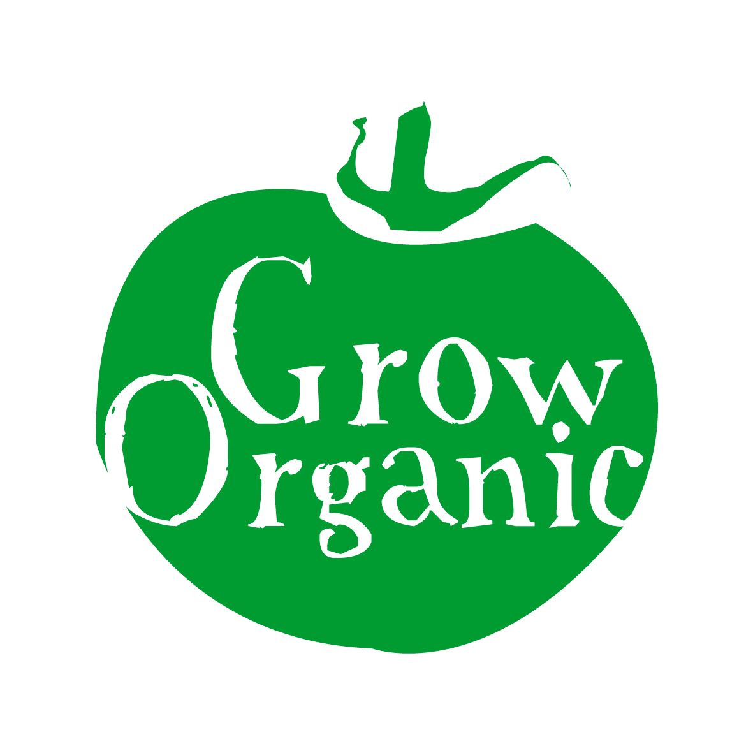
ORGANIC PARSNIPS

Pastinaca sativa Family Apiaceae

Parsnips are one of the most under rated vegetables around. They are incredibly hardy and will store for ages so as we move through the winter months we should be eating more of this delicious versatile vegetable and not eating imported greens which have a huge carbon footprint. Of course you have to like the taste of parsnips to truly agree with me on this one!

Parsnips are relatively straightforward to grow and once they have germinated and become established then they are quite good at looking after themselves. Parsnips are a good crop to grow to break up the soil structure and introduce air and better drainage which is good if the soil is compacted. The root can be quite long on some varieties. Parsnips should be grown in the root section of your rotation.

Sowing
Parsnips just like carrots like deep, well cultivated soil free of stones. Parsnip seeds are quite big so you do not have the rake the soil into a very fine tilth as you would with carrots. It is not necessary to have added manure to the soil recently if it has been manured for a previous crop then that should be fine. It is better to wait until the soil has warmed up before sowing parsnip seeds.

Germination rates for parsnips vary and they are extremely slow to germinate so it is a good idea to sow rows of quick growing crops such as radishes to enable you to keep track of where you sowed your parsnips as the weeds can easily take over otherwise.

Sow seeds as thinly as possible (to avoid too much thinning). Once the seeds have appeared they can be thinned to 6 inches (15cm) apart in rows 10 inches (25cm) apart.

Care
Also like carrots it is important to keep the area where parsnips are sown clear of weeds as if there are weeds in the area the germination can be affected. As germination is slow and can often take over three weeks then you have to keep an eye on the area to make sure that weeds are kept in check so lots of hand weeding is required. Once plants are established and have lots of green leaves then you no longer need to weed as they are good at keeping the weeds down themselves.

As parsnips have a tap root (that is what you eat) they do not require watering unless we have a dry spell of 2-3 weeks in the summer.

Pests
- Carrot root fly can also affect parsnips however if you are also growing carrots they are most likely to go to the carrots instead of the parsnips (download our factsheet on Organic Carrots to find out more)
- Celery fly may also affect parsnips. When it lands on the leaves it causes them to blister. The best way to get rid of it to pick off any affected leaves that you see. This is not a big problem and it quite rare.

Diseases
- Canker is the biggest problem with parsnips. The top parts of the parsnips turn brown. They are still fine to eat but do not look very attractive. The main cause of it is damage from hoeing the crops so that is why hand weeding is advisable if possible. Canker is also more likely to occur on acid soils and wet conditions with bad drainage.

Harvest and storage
Parsnips are best eaten after a frost when the roots sweeten up however after March they tend to get soft and can loose some of their flavour. When harvesting parsnips you can damage them if you use a fork to dig them up or your hand. One trick is to use a spade and dig down the side of the trench exposing the side of the parsnips and then use a fork or your hand to get them out.

Parsnips do not store very well so they are best left in the ground and harvest them as you use them. However if you need to dig them up then and put them in a sack and cover them with damp soil they will last for a few weeks.

