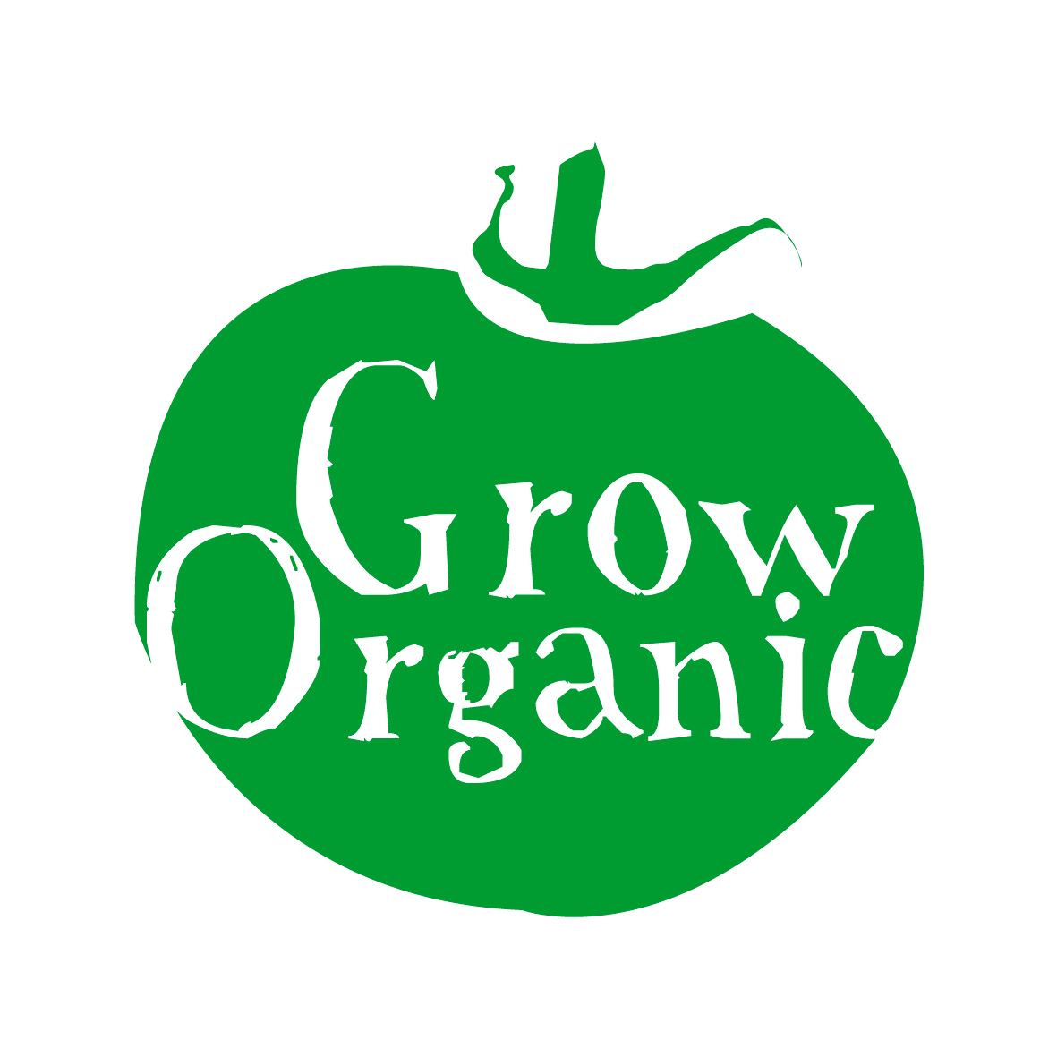
ORGANIC PEAS

Pisum sativum Family Leguminosae

The quality of home grown peas is very hard to beat and peas bought in the shops are almost a different variety such is the difference in taste. Peas are pretty easy to grow and if you have space they are a great treat in any garden as they can be eaten like sweets.

Peas can be divided into two categories depending on whether you shell them or eat the whole pod.

Shelling peas
- Standard peas which are grown for the peas inside the pod. They are generally eaten fresh or frozen.
- Petit pois – these are tiny very sweet peas

Mangetout peas
- Flat podded type you basically eat the immature pods. These peas are very sweet and if they you leave them too long on the plant you can pod them and eat them as standard peas
- Sugar snap peas the pods are round and the peas grow very big in the pod. You can eat the whole thing without shelling them. They have a crunchy texture and have a lovely flavour when they are fully mature

Peas like soil which is fertile and which has had some manure added to it the previous autumn if possible. The soil should be well drained as peas do not like soil which is water logged.
Peas like a bit of sun so sow them in a sunny spot in the garden.

Sowing
Most varieties of peas will need some form of support so be mindful of this when you sow them. The most effective way to sow peas is to weed the area well and then sow the seeds direct into the ground. Sow in a 15cm wide trench at a depth of 5-6cm about 5cm apart (2 inches). In a metre wide bed you should be able to fit two drills into it.

Care
Peas need to be watered after they are sown. Then it is a good idea to mulch them as they need to be kept weed free for the first few weeks. You can use grass-clippings, compost or leaf mould as your mulch, alternatively use cardboard or newspapers to mulch the peas. The mulch will keep the plants moist but if there is a very dry spell water the peas however overwatering will make the peas less sweet.

Peas need to be staked as when they are mature the plants are quite heavy. There are many ways to do this the easiest is to get some chicken wire fencing and attach it to some wooden posts every metre or so and then place the wire fence behind the row of peas. As the peas grow and mature they cling onto the fence with their “tendrils” and grow up the fence. Using support like this also makes it easier to harvest peas as there is easier access to the peas on the plant.

Pests
- Mice can be a real problem once peas are sown as they burrow down and eat the peas and it can be some time before you realise that there is no pea there to sprout. Watch out for disturbance of the soil around where you sowed the peas. There is no real method to prevent the mice from having a feast except to set mouse traps humane or otherwise!
- Birds are also a problem in the early stages as they like to pull small tender pea plants out of the ground. Pigeons will also eat the plants leaving you with nothing put the stalk. If it is a real problem you can cover the peas with netting to keep the birds out
- Pea moths lay their eggs on the pea plants when they are in flower. The eggs hatch into grubs that feed on the peas developing in the pods. Often you do not know that you have a problem until you shell the peas and find the maggots or grubs inside. Covering the peas with a fine netting will deter the adult moths

Disease
- Mildews are the main problem with peas. It tends to affect the pea plant in cool damp conditions. Mildew sets in around August time when most of the peas have been harvested. Make sure to practice a good rotation system which will reduce the problem

Harvesting and Storage
For shelling peas pick the pods while the peas are still small and before the pods get too fat. The best way to tell if they are ready is to pick one and see how it tastes. Often they are better eaten raw than cooked when they are this fresh. Once they get too big the sugar in the peas turns to starch and tastes quite bitter so do not leave them on the plants for too long. Peas can take a while to pick so enjoy the fruit of your labour!

For mangetout flat types pick them when the outline of the pea is just visible in the pod and it snaps cleanly in half. For the mangetout sugar snap varieties pick them when they are green fat and again snap in half easily. If you leave either of these mangetout types of peas for longer on the plant then you can use them as you would shelled peas.

Shelled peas store better than the mangetout varieties. The best way to store them is to shell the pods and then freeze the peas inside. They retain the flavour that way however they are never as sweet as when they are picked and eaten fresh.

With all peas as they grow they develop nodules on their roots which feed the plant nitrogen as it grows. After the season cut the plant down to the base and then dig the plant back into the soil. The nitrogen will be released back into the soil and will be available for any plants that might follow the peas. This is useful to know for your rotations as you can put a crop in the following year like cabbage or potatoes which likes a lot of nitrogen in the soil.

