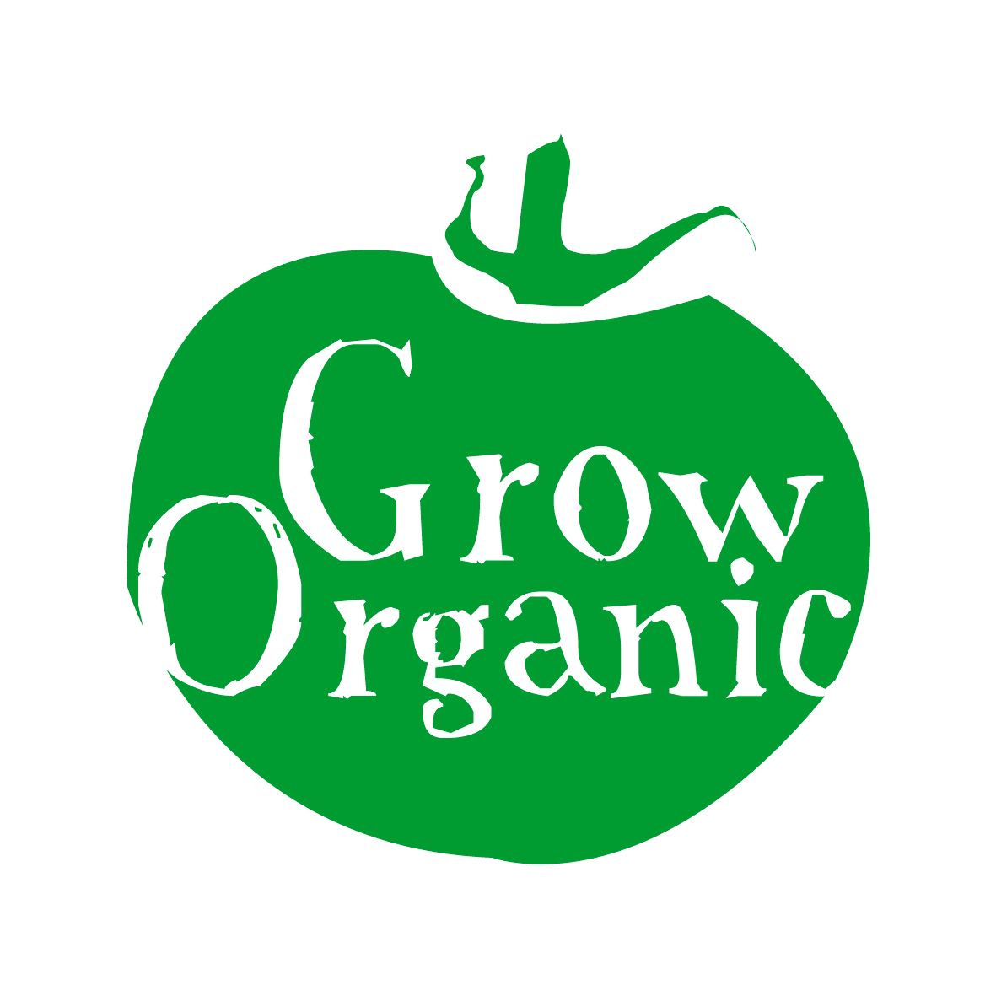
ORGANIC POTATOES

Solanum tuberosum Solanaceae Family

Potatoes are a pretty easy crop to grow. They are a great first crop as they really break up the soil and improve the soil structure. Irish people traditionally tend to love “floury” potatoes rather than “soapy” potatoes. This can sometimes be problematic when it comes to growing organic potatoes commercially as the varieties which are blight resistant tend to be more soapy than floury!

There is a huge diversity in the varieties of potatoes with over 4,000 varieties named around the globe. There is a renewed interest in growing older varieties which makes a great talking point over dinner particularly if you grow some of the purple or blue varieties.

Potato plants grow from tubers, called seed potatoes, rather than seed. You can easily store your own seed potatoes from the previous year’s harvest. Only use the best quality potatoes for seed potatoes. There are different categories of potatoes;

Early potatoes: These mature in 75 - 90 days and are generally out of the ground before the blight season. The yields are not as high with early potatoes and they do not store well however they have an excellent flavour. Colleens, Orla, Sante, Cara and Nicola are good organic varieties to grow.

Second earlies: These mature in approximately 110 days. They produce the tubers relatively quickly and are easy to store. However the flavour deteriorates once they have been dug up.

Early to late maincrop potatoes: These potatoes mature in 135 – 160 days. They store very well but are more susceptible to blight so it is important to grow a blight resistant variety. The Hungarian variety Sharpo Mira has been very good to resist blight in the last few years.

To get an early crop grow potatoes in polytunnels. They can be sown as early as January inside with protective fleece.

Chitting:
Potatoes should be prepared for sowing by chitting them. This is the process of getting them to sprout. It is most important to chit early potatoes, but second early and maincrop potatoes will also benefit from it. The potatoes will have a head start when they are planted and will grow more quickly throughout the year allowing them to be harvested earlier.

When you get your potatoes arrange them in trays somewhere light but cool (about 10 degrees C is ok). Notice that the tubers have eyes, where the sprouts will grow. Lay the potatoes out so that most of the eyes are at the top. When the sprouts are short and green then the potatoes are ready for planting.

Planting:
Early potatoes are traditionally planted before St. Patrick’s Day, second earlies at the start of April and maincrop before the end of April. The traditional way to plant potatoes is in trenches. First dig a long trench and fill the bottom with garden compost or well rotted farm yard manure. Then put the seed potatoes in the bottom of the trench about 2 inches below the soil and then cover the trench with soil. Ridge up the soil over the plants as they emerge from the ground, this is called earthing up the potatoes. Make sure that the tubers are always well covered with soil otherwise tubers become green and are not suitable to eat, this system also gives some protection against blight and controls weeds.

Spacing for early potatoes is 11 -14 inches apart with about 15 – 20 inches between rows. Second earlies and maincrop should be planted 14 – 18 inches apart with 26 – 30 inches between rows.

Make sure that any early plants which are above ground are protected from any frost by covering them with fleece. Keep plants well watered throughout the growing season as potatoes can be a hungry crop.

Pests:
- Slugs and mice are particularly troublesome if you are growing potatoes under plastic or mulch. To minimise the problem do not leave the potatoes in the ground for too long
- Potato cyst eelworms are too small to see but they can kill plants off early, stopping the tubers growing to any size and they can affect tomatoes as well as potatoes as they are in the same family. The plant leaves turn a pale yellow and then dry up from the bottom of the plant upwards. If you dig up a plant you will see the white, yellow or brown spherical cysts up to 1mm in diameter attached to the roots. These cysts are the female eelworms and carry hundreds of eggs each. If you suspect plants are effected dig them up and destroy them. Ground which has previously grown a lot of potatoes is more likely to have potato cyst eelworms so to avoid it make sure that you use a good rotation system.
- Wireworms are a problem if you are growing potatoes in ground which was formerly grassland. They are shiny orange worm, 10 – 15mm long and 1mm across with a segmented body. If you can not avoid growing potatoes in what was grassland then be prepared to lose some of your crop to wireworms who bore small holes in the potatoes.

Diseases:
- Common scab is a cosmetic problem and it happens in soils which are not acidic enough. Do not lime the soil and add more farmyard manure to the soil to keep it more acidic. Some varieties are more resistant to scab than others.
- Blight is one of the most problematic issues when growing potatoes in Ireland. Early potatoes are generally not affected as they are usually out of the ground before the blight season. In organic gardening spraying for blight is not an option so the best advice is to grow potatoes that are more blight resistant which is very successful. There are many excellent blight resistant varieties on the market (see above). Blight is worst in warm, moist conditions from mid-summer onwards. Brownish black spots appear on leaves on stems. Eventually spores washed into soil and affect tubers. If the crops are very badly affected then towards the end of the summer cut back the plants to within 2 inches of the ground, remove and burn leaves and stems. Then leave the plants in the ground for 3 weeks before lifting so that spores on the surface die off. Traditionally a mixture of bluestone copper and lime was used to combat this. It is also known as bordeaux mixture. The copper is toxic to the blight spores. However there is also a concern that some copper might be taken up by the potatoes so now people prefer to grow more resistant varieties.

Harvesting:
Early potatoes are ready to harvest when they start to flower. Maincrop should be dug as soon as foliage dies down usually in September. Remove all tubers from the ground to eliminate the risk of over wintering blight spores. Store disease free tubers in a cool place rub off any soil from the tubers when storing them.

