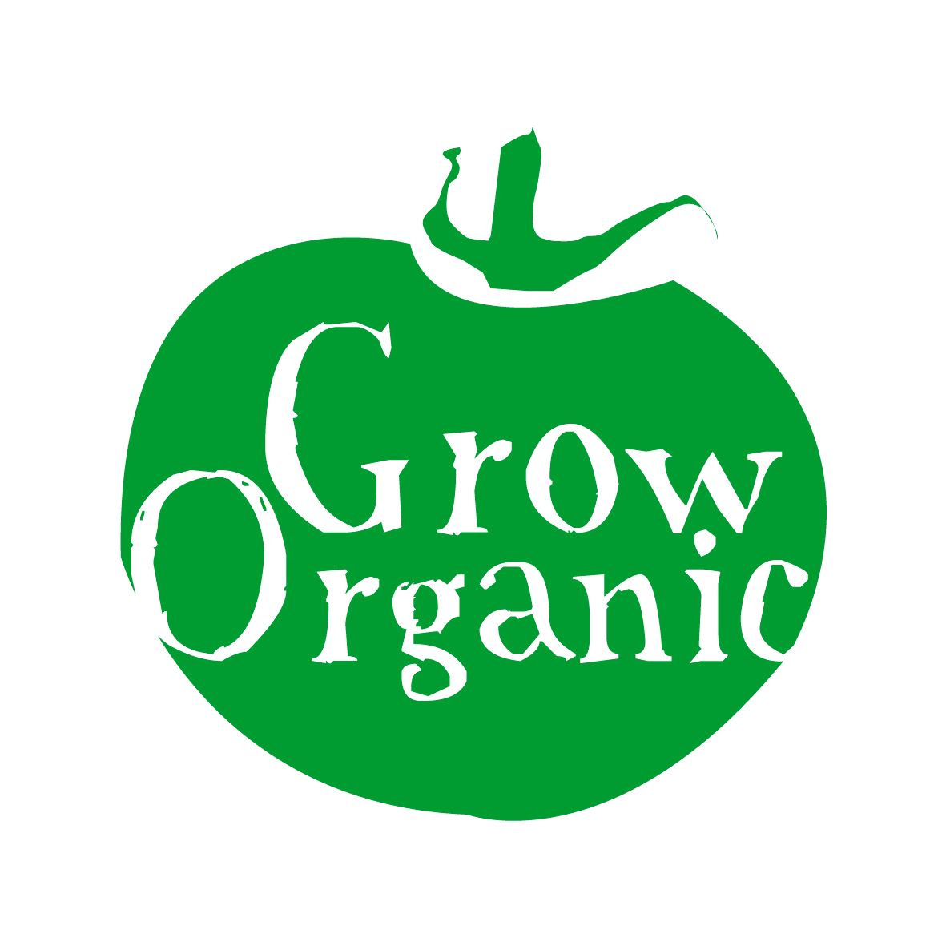
ORGANIC TOMATOES

Lycopersicon esculentum Solanaceae Family

It is hard to beat the taste of a ripe tomato picked fresh from the vine. Growing tomatoes in Ireland can be very tricky particularly if you are growing them outdoors. It is very weather dependent and tomatoes really require a lot of sun to ripen and sweeten.

If you do not have a greenhouse/polytunnel and it is your first time growing tomatoes pick a variety that grows well outdoors. There are literally hundreds of varieties of tomatoes to choose from experiment with two or three different varieties. There are 2 main types of tomatoes: Cordon or indeterminate varieties which grow upright with support and bush varieties that are lower more rambling plants.

Tomatoes are in the same family as potatoes, peppers and aubergines so remember that when you are planning your rotation. The flowers are very similar on all of the above plants. There are many different kinds of tomatoes from cherry tomatoes, roma tomatoes to the large heirloom or beefstake tomatoes if you have space experiment a bit and you may be surprised by the results.

Sowing seeds
Early birds start tomato seeds off in January however you will need a heated propagator to germinate seeds at that stage of the year. Most people start tomato seeds in the middle of March. Sow seeds in the usual way (see the Grow Organic factsheet on Sowing Seeds) germination is usually optimum at about 20 degrees C. Germination of tomato seeds is slow and can take anywhere from 7 -21 days so be patient! Once seeds have germinated and plants have reached a reasonable size (approximately 4 leaves) then you will need to transplant the seedling into a bigger pot. A 10cm pot is what is normally used. Fill this with potting compost not seed compost as potting compost will have more nutrients in it. Then transplant the seedling taking care not to damage the roots into the new pot where you will leave it to grow until it is ready to transplant into the ground. This process usually takes around 8 weeks.

Planting
Tomato plants are ready to be transplanted into the ground when the first truss is starting to bloom ie when one branch of the plants starts to have flowers appear on it. To prepare the ground for planting dig in lots of well rotted farmyard manure as tomatoes are heavy feeders and will require lots of nutrients in order to produce a heavy crop. If you have some home made compost you can also add it to the soil as this will be good to retain moisture in the ground.

Plants need to be spaced at about 18inches or 45cm apart to give them enough room to grow. Indeterminate and bush varieties both need some form of support or else the plant can break with the weight of the fruit so staking plants is important. The easiest way to do it is to get a long piece of string (at least 10ft for indeterminate and about 4ft for bush) and tie the string around the root of the plant and then bury the string with the root of the plant when you transplant it. Then either use a stake with the plant or use an overhead frame to tie the string to. As the plant grows you use the string to tie it to the stake or overhead frame to support the plant. Each year the growth of tomato plants never ceases to amaze as they really are prolific plants.

Care
Tomatoes are not the easiest plants to grow and do require some attention. They are self fertile so under warm conditions will pollinate themselves, outdoor varieties never really have problems with pollination as they are more exposed to wind. Good ventilation is required if it is very warm in a polytunnel. Tomatoes ripen from the bottom truss up so when the plant is in flower tap the support to spread the pollen and ensure fruit set.

Watering is very important especially as the fruits develop. Outdoor plants are obviously harder to control but if there is a long dry spell make sure to water the plants at least every second day. Indoor plants are more vulnerable and problems can develop such as the flowers fall off, fruit splits, or the plants develop blossom end rot or blight. Some people water plants every day at the same time to reduce fruit splitting ie morning or evening. Other people water them every day until the fruit sets then they reduce it to once a week and once the fruit starts to ripen they do not water them at all. The reason for this is to keep the moisture levels and therefore fungal disease down. If you choose the second method then you need to ensure that you are giving the plants a comfrey liquid feed every week if possible twice a week (download the Grow Organic factsheet on Liquid Feeds for more information).

While tomato plants are fruiting they require a lot of potash. The easiest way to get this is from a comfrey feed. You can make your own comfrey feed or alternatively you can buy an organic tomato feed from your local garden centre. No matter how often you choose to water your plants make sure that all plants get a comfrey feed regularly throughout the growing season this encourages plants to flower and therefore fruit. If you are away for a long period of time during the summer have someone water the tomatoes if possible as they are in the high maintenance category!

Pruning
Cordon or indeterminate tomato plants need to be severely pruned during the growing season. Cut each plant back so that there is one or maximum two main stems. Then leave about 6 -8 branches with trusses on them and remove the rest. Then once you are happy with the number of trusses remove the growing tip of the plant. This will ensure that the plant puts its energy into producing fruit rather than leaves. Bush varieties as their name suggests tend to bushier and have more leaves so require less pruning however if you feel that the fruit is being covered too much by leaves removes some branches so that the sun can ripen the fruit.

Don’t be afraid to be brutal as tomato plants are quiet resilient and will grow back. You can also remove side shoots which are shoots growing in the axil between the stem and the petiole again this ensures that no energy is wasted in the production of side shoots rather than fruit.

Pests
- Whitefly can affect indoor crops. By growing Tagetes (French Marigolds) you can reduce them as whitefly don’t like the smell of the marigolds
- Greenfly can also appear on your tomato leaves so check them regularly. To get rid of greenfly the most effective way is to physically remove them from the plant. Alternatively you can wash them with a garlic spray or hose them heavily with water however this may also damage the plant itself
- Red spider mite is often present in polytunnels and especially if the polytunnel is very dry. A parasitic nematode can be used to remove the red spider mite. The mite is microscopic so not visible to the eye you know when you have it as the plant has a web woven around it however at this stage it is often too late as the plant may be dying from the inside out

Diseases
- Blossom end rot is caused by irregular feeding and watering and also by a lack of available calcium. The fruits have sunken in lesions which turn brown and then black and hard. Make sure that the soil is damp but not soaked
- Blight also affects tomatoes and if you get blight on your potatoes then it will most likely find its way to your tomatoes. It is encouraged by warm, damp conditions to keep indoor tomatoes well ventilated. Remove any infected leaves which will turn brown/black to reduce and minimise damage and spreading of the airborne fungus
- Botrytis is a fungal problem which appears as a grey mould. It tends to be a problem at the end of the summer due to cool damp air. Again try to minimise the problem by ensuring that tomatoes are well ventilated and remove any plants or leaves infected.

Harvesting and storing
Indoor varieties are ready to harvest first and may be ready at the end of June. Outdoor tomatoes take longer and can be very weather dependent. Tomatoes are easy to harvest just pick the fruit off the vine take the small green stalk with it. If you examine a tomato plant carefully you will see just above the fruit on the stem that there is a small line which the fruit hangs onto the stem at break the fruit from this point. If you grow a variety of plants you will have a good supply of tomatoes from June until the autumn. The first frost will kill any outdoor plants.

Tomatoes do not store well unless you dry dehydrate or can them. All of this takes time but means that you can enjoy your tomato harvest well into the winter. If you have a glut of tomatoes exploring the above methods is a good option. If at the end of the season you find that you have a lot of tomatoes you can ripen them on a sunny windowsill. If you have a glut of green tomatoes the best thing to do is to make a tomato chutney.

