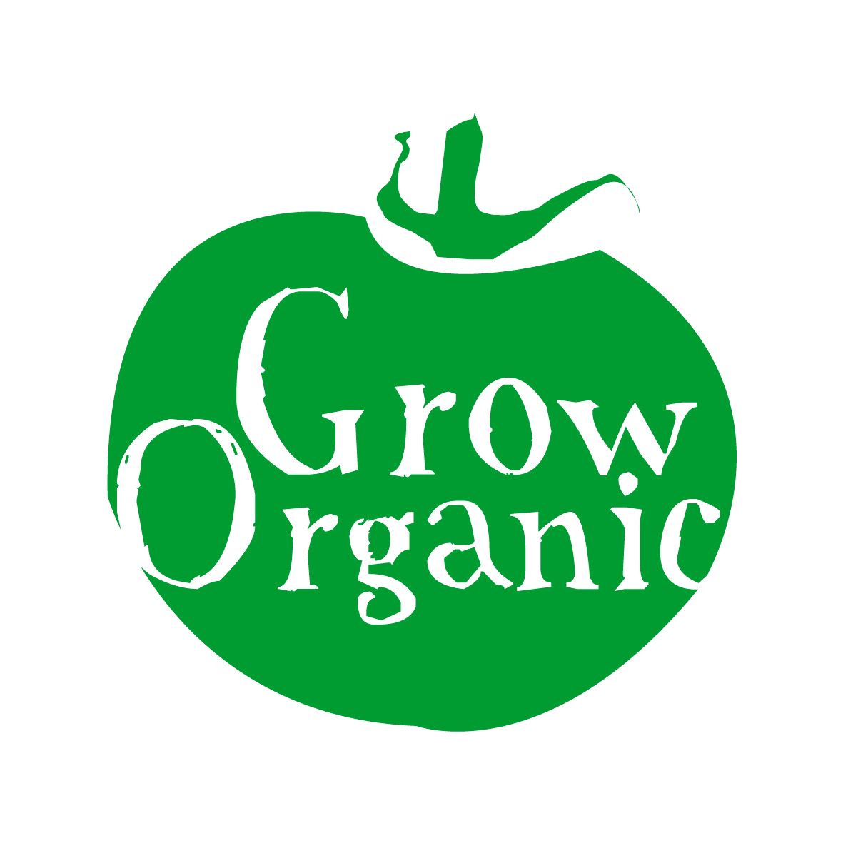
PESTS AND DISEASES IN THE ORGANIC GARDEN

As outlined earlier healthy organic soil is important to sustain healthy organic plants. If crops and plants in the garden are healthy then they are better able to resist attacks from pests and diseases.

Ways to reduce pests and disease in the organic garden;

- Follow a strict rotation plan in the garden
- Grow plants from seed if possible
- Prevention is better that cure!
- Be vigilant in the garden and when you spot a problem try to take care of it immediately otherwise it can quickly get out of hand
- Use biological pest control in the garden
- Attract wildlife into the organic garden to keep pests to a minimum
- Use organic slug pellets
- Grow flowers and plants in the garden that attract beneficial insects into the garden
- Use permitted pest control
- Get to know the good and bad guys in the garden so that you know what to encourage into the garden and what to keep out
- It is good practice to keep tools and equipment clean to prevent transferring disease from one plant to another
- Do not place diseased plants in the compost heap
- Encourage diversity in the garden and use minimal intervention if possible
- Learn from your mistakes!

Healthy plants can be quite resilient so with your gentle guidance they will recover any attacks and continue to produce great organic food!

