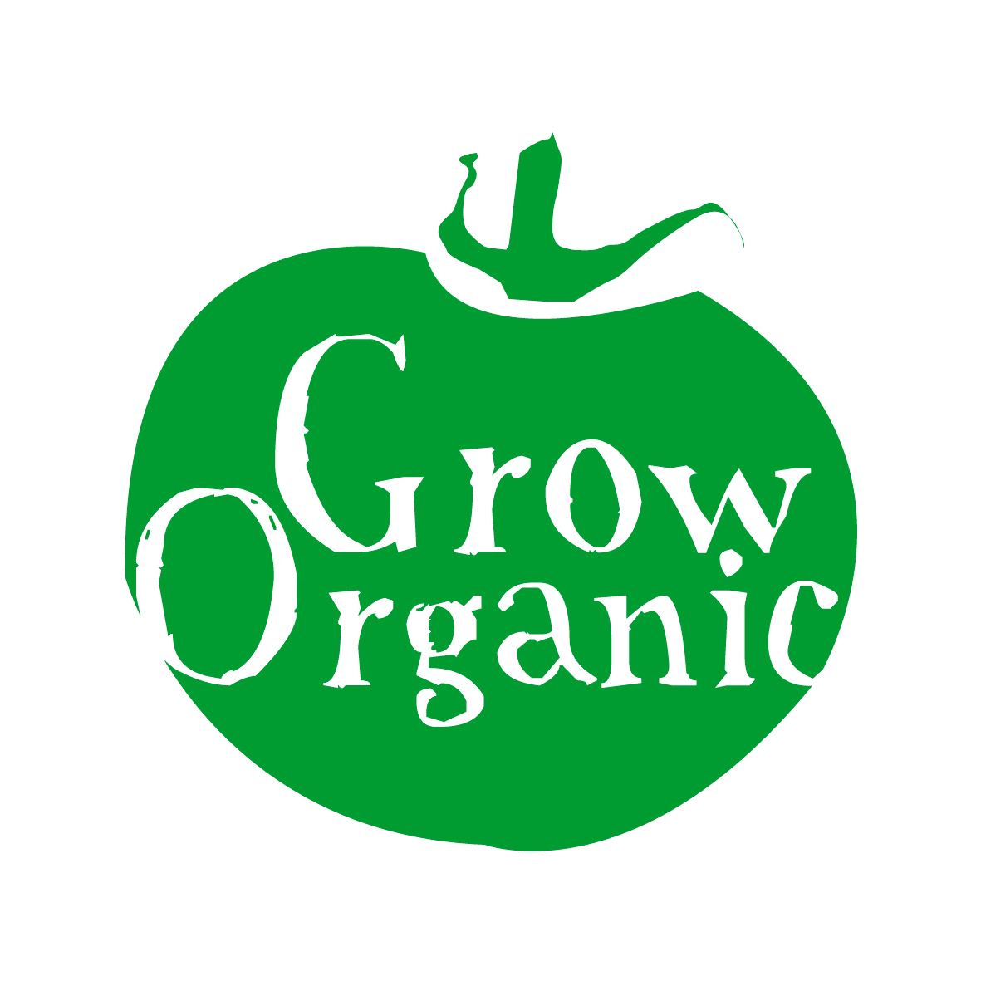

ROTATION OF CROPS IN THE ORGANIC GARDEN

Crop rotation is the practice of growing related vegetables in different areas in consecutive years. Vegetables from the same botanical family are susceptible to the same pests and diseases.

If members of the same family are grown in the same place year after year there is a tendency for soil borne pests and diseases to become established. In small plots there may not be much advantage in moving crops just a few meters away but there are other benefits;

- Nutrient availability; vegetables differ in their nutrient requirements so moving them around the growing area helps to prevent the soil becoming depleted locally and makes the best use of the soil
- Soil treatments; some crops need soil amendments to do well, others make good use of residual fertility left by a previous crop. Grow crops with similar requirements together so you can apply the appropriate soil treatments for them
- Weed control; some vegetables like marrows and potatoes produce weed suppressing foliage and are easy to weed. Alternating vegetables helps to keep weeds under control
- Soil structure; plant roots occupy different levels of the soil. Alternating deep with shallow rooting vegetables has a positive effect on the soil structure.

Step 1
Identify the main crops that you would like to grow. What crops do you or your family like to eat? If you are in a school garden try to grow crops which will be ready for harvest before the school holidays eg, courgettes, lettuce and salad leaves, early potatoes to name a few. You can also grow crops which will be ready for harvest in the autumn time eg pumpkins etc.
Make your wish list of crops!

Step 2
When you have drawn up your list of crops that you want to grow, identify the family that each crop belongs to (download our fact sheet Vegetable Families for more information). Group the crops from the same families together eg potatoes, tomatoes, peppers, aubergines are all part of the same crop family.

Step 3
Crops from the same families generally have similar requirements eg cabbage, cauliflower and broccoli are all part of the same family and they require a lot of manure before they go into the ground and they will occupy a similar length of time in the ground.

Step 4
An example of a 4 year crop rotation for the main crop families is as follows;

Alliums (Liliaceae Family) Bed 1
Onions, garlic, leeks, spring onions and shallots.

Brassicas (Cruciferae Family) Bed 2
Cabbage, cauliflower, broccoli, kale, brussels sprouts, Swedes, turnips, rocket, radish and pak choi.

Legumes (Leguminosae Family) Bed 3 (these crops fix nitrogen in the soil)
Peas, mange tout, french beans, runner beans and broad beans

Solanaceae Family Bed 4
Potatoes, tomatoes, aubergines and peppers.

This is the layout for year 1. In year 2 the crops that were in bed 1 move into bed 2, bed 2 moves into bed 3, bed 3 moves into bed 4 and bed 4 moves into bed 1.

This rotation continues for 4 years as each crops moves into the space occupied by the previous crop the previous year. In the fourth year the crop which was originally in bed 1 returns to bed 1. This is a simple crop rotation which can easily be followed.

Crops that do not fit into the larger families but you still wish to grow may be grouped together eg lettuce, spinach, beetroot and carrots.
In order to make the rotation simple focus on the bigger crop families that you are growing and then stitch the smaller ones in around that. For example you will need more space to grow potatoes than lettuce so design your beds accordingly.

Perennial vegetables (vegetables which come back year after year) do not take part in the rotation even if they are members of the main families, eg Globe artichoke, rhubarb and asparagus. They remain in the one plot and can be changed into another plot over time.

