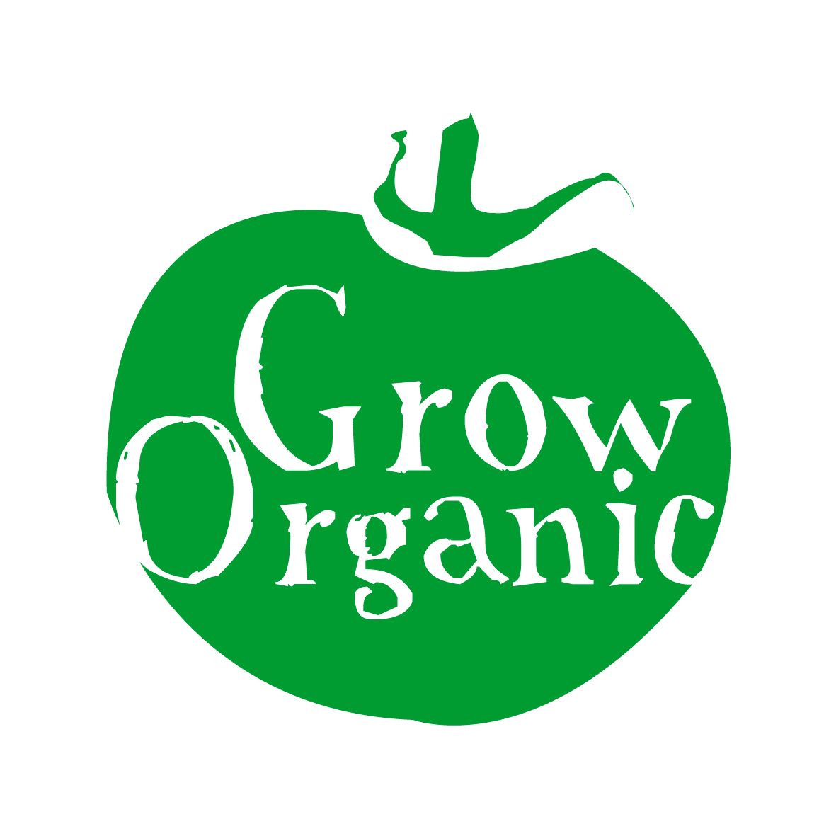

SOIL

Soil is one of the key areas of importance in the organic garden. Soil fertility is essential so that plants can thrive in the garden. If your soil lacks nutrients then plants will suffer and have problems resisting pests and diseases. Remember in the organic garden healthy soil = healthy plants.

Soil is a diverse ecosystem full of life in the form of insects, bacteria, fungi and worms all of which help to maintain soil structure and fertility. It is the job of the organic gardener to make sure that this ecosystem is kept in balance. It is important to ensure that soil nutrients used to grow plants and sustain them during their lifecycles are replaced in the soil.

SOIL TYPE

- Get to know your soil type there are different types of soils and this will determine the plants that can grow and the soil conditioners that you should add to the soil to improve it
- Clay, sand, gravel, silt, stones all combine to make up soil type. When you dig your soil if it is clumpy and sticks together well then it is probably a clay based soil. If the soil particles easily fall through your fingers then the soil type is mainly sandy. In reality most soils are a mixture or what is called a loam.
- If you have a clay soil it will hold nutrients and water well but will tend to get water logged in wet conditions and be slow to warm up in springtime. If you have sandy soil it will be free draining and therefore will not hold water or nutrients in warm weather but it will warm up quicker.

ORGANIC MATTER

- All soil needs organic matter this will break down and add humus to the soil. This humus layer is the layer of soil which contains the nutrients and which plants need to grow and thrive
- You can add organic matter to the soil at any time but the best time in either in the autumn which allows it to decompose and be incorporated into the soil or alternatively in the springtime before planting
- Plant organic materials such as household compost, green manures, garden or allotment compost, leafmould, shredded woody materials and organic mulches all improve soil structure and fertility
- Animal organic materials such as well rotted manure from chickens, horses or cows is an excellent material which will also improve soil structure and fertility *
- Fertilisers from plant, animal and mineral sources are used in the organic garden to add plant food to the soil
- Use a strict rotation in the organic garden to ensure that soil nutrients are not depleted and pests and diseases are controlled

*You need to ensure that the farmyard manure that you use is taken from animals which has not been fed any GM (genetically modified, many animal feeds contain soya or maize to build protein and these may have been grown using gm techniques) ingredients. Ask the farmer who has supplied to manure to check if there are any GM ingredients in the animal feed.

