THRIVING ORGANIC OFFALY

As Spring starts in earnest the Clancy’s at Clanwood Organic Farm are busy planning for the year ahead. This thriving organic business won two major awards in 2010 and so far this year they have won a Silver Business Award with the County Offaly Enterprise Board bringing recognition and attention to their wonderful organic products. “Winning two awards last year lays down a steep marker to beat this year but we are up for the challenge and already have one under our belt” laughs Orla. “Awards are great as they validate what you are doing however we are passionate about what we do here at Clanwood Farm so we are confident that our products are top of the range and our customer satisfaction reflects that”. Sean and Orla began farming in 2005, leaving behind two professional occupations with pensions to try their hand at farming. The main reason was to bring more flexibility into their routine and with two small kids I am sure many people empathise. “We wanted to give our kids the best that we could and now we are delighted that we made the transition as our quality of life as a family has increased dramatically”.

The Clancy’s began farming organically in 2007 as they felt it offered them more options and in 2009 they tried their hand at direct selling in order to maximise returns. “It has been very successful for us and our farm and it suits our business model. We work very hard to produce high quality products and in return we get a good price as there is no middle man. We enjoy working directly with the customer and feel that it is educational for everyone involved” said Sean. In 2009 they purchased a mobile catering unit and “The Organic Kitchen” was born. Now a regular feature at events around the country such as the Electric Picnic, Oxygen and the National Ploughing Championships the Clancy’s have enjoyed this new dimension to their business. They employ local people to help out at events where their organic burger is achieving critical acclaim. “We use cheese, bread for the baps, and salad leaves all from local organic producers so we are really carving a niche for ourselves and putting organic Offaly producers on the map” said Orla.

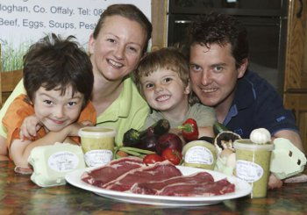

(Orla and Sean Clancy with their boys and some of the products produced on the farm)

The complete range of products on offer from Clanwood Farm are soups (in winter), humous, pesto (in summer), eggs, and a variety of meat products. To buy their products online check out www.clanwoodfarm.com or you can buy from them directly by contacting Orla @ 087 6494477. They are also members of the Shannon Harbour Farmers Market which is held every second Saturday from half ten to twelve. A range of independent shops in Dublin also carry some of the Clanwood products.

