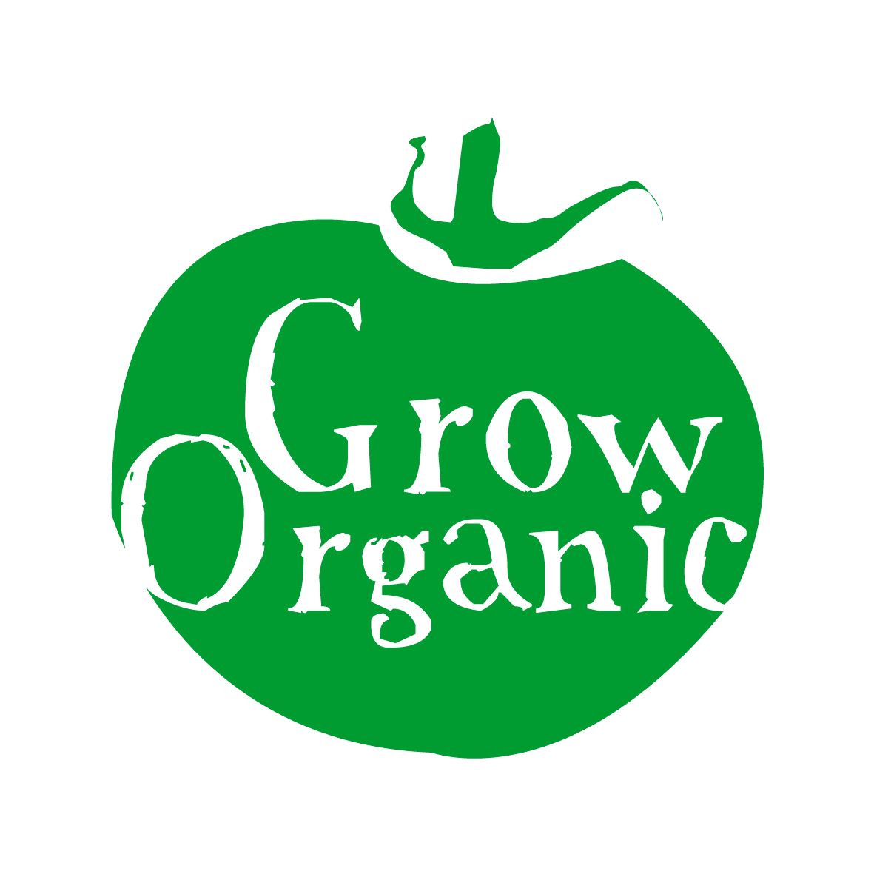

USEFUL RESOURCES FOR ORGANIC GARDENING

BOOKS

- Grow your own Vegetables by Joy Larkcom
- The Organic Salad Garden by Joy Larkcom
- The Encyclopaedia of Organic Gardening by Garden Organic (UK)
- Four Season Harvest by Eliot Coleman (US)
- Grow your own Veg by Carol Klein (UK)
- The Complete Gardener by Monty Don
- The Organic Garden Book by Geoff Hamilton (UK)
- The Organic Garden by Bob Flowerfew (UK)
- Organic Gardening by the RHS (UK)
- Month by Month Organic Gardening by Laurence D Hills (UK Check that this is till in print)
- The Rodale Guide to Composting (US)
- Permaculture by Bill Mollison (AUSTRAILIA)
- Trading Places by Michael Kelly (IRL)

MAGAZINES

- Organic Matters Magazine (IRL) published bi-monthly by IOFGA

WEBSITES

- IOFGA and Grow Organic (IRL) www.iofga.org
- Organic Matters Magazine (IRL) www.organicmattersmag.com
- Garden Organic (UK) www.gardenorganic.org.uk
- The Edible Schoolyard Project (US) www.edibleschoolyard.org
- The Soil Association (UK) www.soilassociation.org
- Get Growing (IRL) www.getgrowing.ie
- Grow It Yourself (IRL) www.giyireland.com
- Trevor Sargents kitchen garden www.trevorskitchengarden.ie
- Organic Gardening (UK) www.organicgardening.com
- Grow Organic Food (UK) www.organicgarden.org.uk

