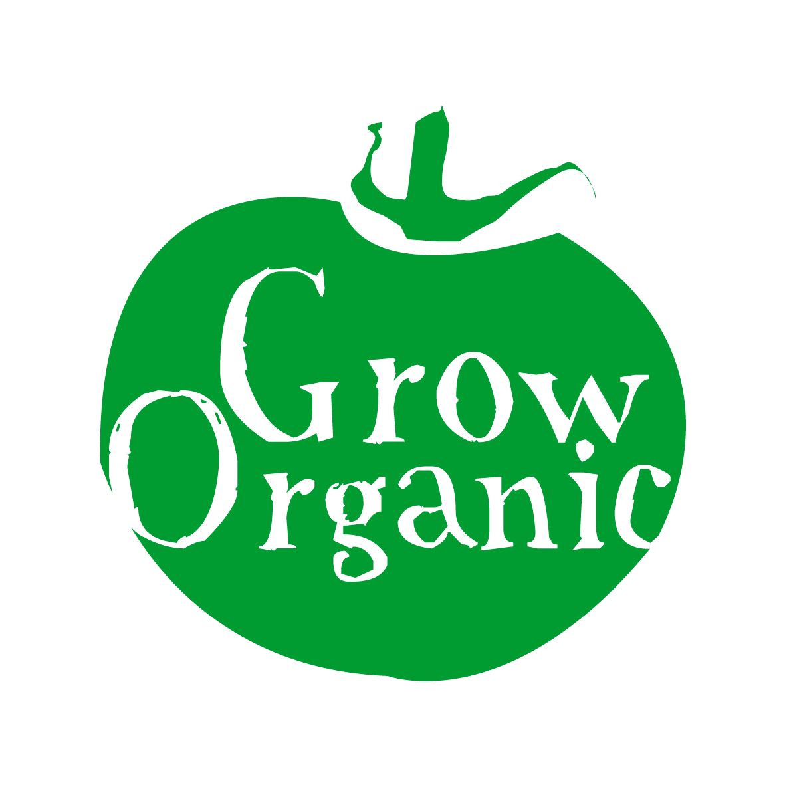

COMPOST IN THE ORGANIC GARDEN

Homemade compost is one of the most vital aspects of the organic garden. Whether your garden is a small allotment or a big school garden one of the first jobs is to make a compost heap.

Tips for making good compost;

- Good compost should be dark, rich and sweet smelling not a sludgy green mess
- Almost 40% of waste from a regular household bin can be composted reducing the amount of waste for landfill
- If using a compost bin use one that is easily accessible, well insulated and has a lid
- Keep your compost bin in a sunny position in the garden
- The key to good compost if the right mix of ingredients
- Meat, dairy and cooked food should be avoided as they will attract vermin
- Materials are divided into 2 categories green and brown, good compost contains a mix of roughly two thirds green and one third brown
- Green materials are rich in nitrogen and includes vegetable waste from the garden, vegetable peelings from the kitchen, nettles, comfrey, small amounts of grass cuttings, tea bags/leaves and coffee grounds, poultry manure and bedding, animal manure from cows and horses in small amounts
- Brown materials are rich in carbon but are slower to break down in a compost heap, materials include shredded newspapers, egg boxes, hedge clippings and woody prunings, cardboard, bedding from vegetarian pets such as rabbits, wood shavings and sawdust, leaves can be used but making leafmould is a better use of leaves
- Wood ash can be also be used in small amounts
- Composting is a great way to recycle nutrients in your garden

If you are in a restricted space it is better to use a compost bin that keeps your compost confined. Most County Councils sell adequate compost holders or you can also purchase some in garden centres. There are also some very good designs available on the market such as the compost pig.

However if you have space the best method to use is a three bay bin. This allows you space to store well-rotted compost, a place to pile up new material throughout the year and somewhere to leave last years garden waste to rot down thoroughly. The bins can be made from recycled pallets or alternatively you can build one using pressurised timber. By having three bins on the go you are never short of a supply of compost.

The quickest way to make compost is to collect your ingredients (remember the green and brown mix listed above) and then make the heap on the one day. You should start the base of the heap with woody materials such as non-diseased pruning or cuttings. Then gradually add layers of your other material.

Start by adding a layer of green nitrogen materials, then a layer of brown materials, follow with 2 layers of green materials etc. As your heap will generally contain more green material than brown you will have more layers of green material. Then when you have finished adding all your layers leave the compost heap.

Gradually the heat will build up and the bacteria and micro-organisms will start decomposing the organic matter in the compost heap. After a week or so using a spade turn the compost heap, repeat this after another week and then once again. By turning the compost heap you are allowing air into the heap which speeds up decomposition. Your compost heap should be covered to allow the heat to build up however it should also be a little moist so add water the heap once a week if necessary. After about a month to 6 weeks your compost should be ready for use.

Alternatively you can leave room in the garden for a heap of compost which you gradually keep adding to over the growing season. This type of compost is never turned so it is anaerobic, the temperature is never very high. This type of compost should also be covered if possible or else any nutrients will be washed out by the rain.

To incorporate compost into the soil either dig it in with a spade or if the compost is very fine you can leave it on your beds as a top dressing.

