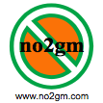

LAUNCH of
no2gm Campaign
by
Clodagh McKenna
@
Dún Laoghaire-Rathdown Farmer’s Market
in
The People’s Park
Dún Laoghaire

Sunday 16th October 2011
(UN World International Food Day)
12 noon – 3pm
Family Event:
Puppet Show, GM Free Food Tastings & Lots of Information.
